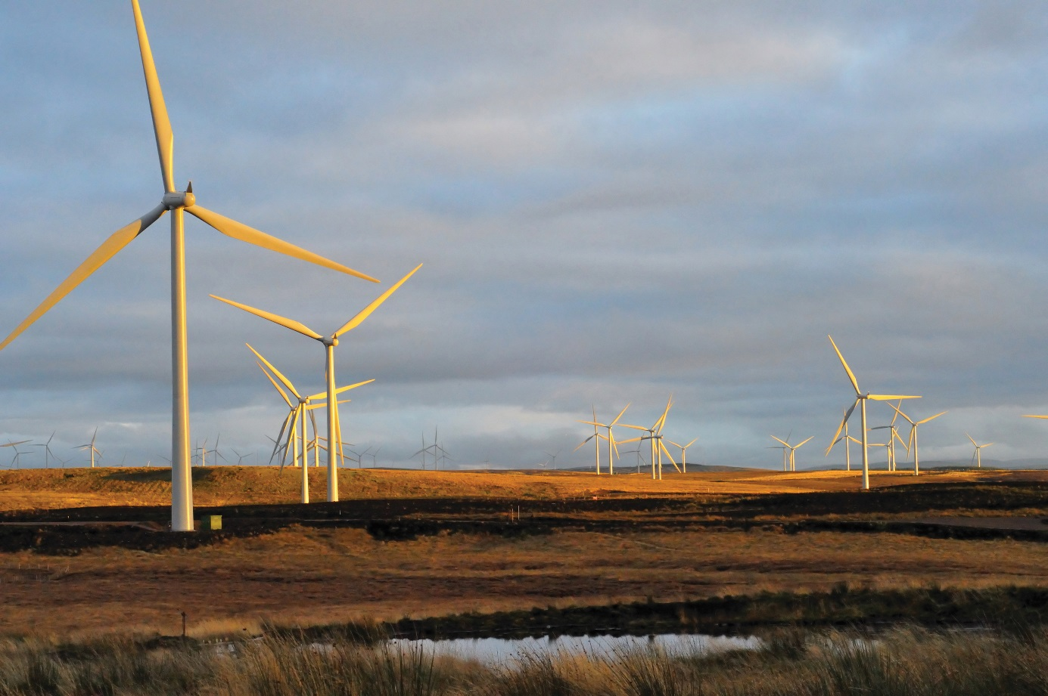

Royal Society of Edinburgh Research Network in the Arts and Humanities - Connecting with a low-carbon Scotland

The network is funded by the Royal Society of Edinburgh under its Research Network in the Arts and Humanities award scheme. It involves humanities scholars from the universities of Stirling, Warwick, Durham, St Andrews, Edinburgh, Strathclyde, Dundee, Queen Mary University of London, Dublin City, Exeter and the Open University, as well as Creative Scotland, the Crichton Carbon Centre and Creative Carbon Scotland.

The network objectives are:

- to establish an interdisciplinary research network between humanities scholars on the development of a low-carbon society in Scotland;
- to develop public knowledge and understanding of the move to a low-carbon society as a cultural happening in Scotland and to engage with Scottish cultural institutions and relevant non-academic actors in Scottish civil society;
- to organise an interdisciplinary academic conference and free public engagement events to facilitate knowledge exchange about how cultural production and representations in Scotland can help facilitate Scotland’s transition to a low-carbon society;
- to publish a peer-reviewed, interdisciplinary research monograph exploring how moving to a low-carbon society is presented as a cultural phenomenon in Scotland in powerful narratives – literature and theatre, law, politics, history, visual arts and media; and
- to formulate a major proposal for AHRC research grant funding to develop the network and themes further.

If you are interested in finding out more about the network or participating in it, please contact Professor Gavin Little at g.f.m.little@stir.ac.uk

Description of Project

It is estimated that in the period 1751-2008 the UK produced more carbon dioxide (C02) per person as a result of burning fossil fuels than any other country. Scotland’s share of this is, inevitably, significant, as is its consequent moral responsibility to mitigate the effects of climate change by reducing C02 emissions.

Scotland is well placed to take advantage of its considerable potential to address climate change through renewable energy and to benefit economically from the ongoing industrial revolution in renewables – as it has benefited from its coal, oil and gas industries. The Scottish Government has therefore set very ambitious statutory targets to facilitate the transition to a low-carbon society through the reduction of GHG emissions and the development of renewables.

While the interrelated issues of climate change, fossil fuel use and low-carbon transition have often been seen primarily as the preserve of science, technology, engineering and economics, there is growing recognition in academia and society generally that responding to climate change requires a fundamental shift in approach: moving to a low-carbon future is an essentially social act.

While many support the idea, there is a lack of public engagement with achieving it. Thus far, transition has either been a “top-down”, technocratic process or left to uneven and ineffectual individual acts of environmental awareness.

Given the growing understanding of the distinctive power of cultural approaches in effecting transition, there is a real opportunity for the humanities to help bridge the gap in Scotland. Important cultural influences which impact on Scottish public perceptions of transition have not been brought together and explored coherently. Our network proposes to do this in order that transition can be addressed anew and attitudes changed more effectively.

The network will bring together scholars from across the humanities – literature and theatre, history, politics, law, the visual arts and media studies - to facilitate the creation of a low-carbon society in Scotland through the development of shared interdisciplinary understandings of the interrelated challenges posed for Scotland by climate change, patterns of energy use and the process of transition.

These insights will contribute to the development of an overall narrative for Scotland and can underpin the establishment of a common platform for debate in Scottish civic society, as well as academia: Scottish cultural institutions (such as Creative Scotland) will be able to participate in the network.

What are the Scottish stories of transition?

There is a wide range of different Scottish narratives on the histories and futures of communities; national and local identities; democracy; human rights; poverty, opportunity and prosperity; sustainability; the connections between Scots and their natural heritage; and the inter-relationships between citizens, industrial vested interests and the state.

Coal, oil, renewables and now hydraulic fracturing, or “fracking”, are part of Scottish political narratives on prosperity, modernity and opportunity: they are also contested issues in Scottish constitutional debate. Stories and visual images articulating the threats posed to iconic Scottish landscapes by fossil fuels, nuclear power and renewables also have strong cultural resonances.

And while political and legal narratives on energy use and transition are highly authoritative as expressions of power, they are remote from citizens: arguably, this reflects a dislocation of politico-legal authority from the Scottish public imagination.

Interdisciplinary collaboration is needed to deepen and bring together understanding of key themes in narratives of this sort. Evaluating how different Scottish narratives present the issues involved in making the transition to a low-carbon society will contribute to thinking on how best to influence public attitudes and facilitate change.

Network Activities

The network has two core activities: (i) research development; and (ii) public engagement.

Research Development

Panel Meetings

There will be a series of meetings of academic panels which will develop key disciplinary and inter-disciplinary network strands.

The panels will:

- explore specific forms of narrative which articulate different representations of the transition to a low-carbon Scotland through reading and writing group discussions/workshops;
- develop a theme-based approach to analysing narratives (e.g. narratives on identity and community; industrial development and environmental sustainability; rights and justice; and citizens, industry and the state);
- develop disciplinary perspectives on specific themes for interdisciplinary consideration, in order to identify common issues and develop interdisciplinary understanding; and
- create a series of panel reports, building an overall interdisciplinary narrative that reflects a broad cultural understanding.

The panels are as follows:

1. Literature and theatre
2. Politics
3. Law
4. Visual arts
5. Media
6. Plenary

Conference and Monograph

There will be an interdisciplinary conference held at the University of Stirling in 2017.
This conference will bring scholars from Scotland, the UK, Europe and North America together. The proceedings of the conference – along with more substantive chapters – will be published as an edited monograph.

AHRC Application

The work of the panels will be taken forward to develop a major AHRC grant application.

This will build on the experience of the network and the links that have been made to create a larger international and comparative project to develop interdisciplinary understanding of the impact of different cultural narratives on the transition to a low-carbon future across Europe.

Public Engagement

The second key activity of the network is to stimulate debate and develop understanding beyond the academy.

There will be two free multi-media public engagement events in 2017 which will be informed by liaison with Scottish cultural institutions.

