JOINT UNIVERSITY OF STIRLING AND STIRLING STUDENTS’ UNION MENTAL HEALTH STRATEGY 2021-2024

The value of positive mental health to the University of Stirling
Protecting and enhancing the mental health and wellbeing of our students and staff is of utmost importance to the University. It is recognised that, to perform, thrive and succeed, whether as a student or as a colleague, members of our community need to be mentally well and emotionally resilient. The links between mental health, confidence, resilience, performance and impact are intrinsic and are acknowledged by the University. Building and protecting strong and positive mental health amongst our workforce and student population is recognised as a fundamental enabler for institutional success.
Mental health exists on a spectrum: every individual has mental health, and – like physical health – sometimes it is optimal and other times it is not. Similarly, some people have diagnosable mental health conditions whilst others do not. Those with diagnosed mental health conditions may be managing them effectively. Likewise, people without diagnosed mental health conditions might have optimal mental health or, at some points in their life, may be in crisis.
The contributors to mental health or mental ill health are varied and can include personal circumstances, life events, issues relating to work and study, living environment, and the presence of diagnosable mental health conditions. All these factors can vary and the combination of each will affect mental health on a day-to-day basis. The University cannot control all these aspects and contributors, but it can take steps to create and sustain a work and study environment and culture that values good mental health, and to be a supportive employer and educator.

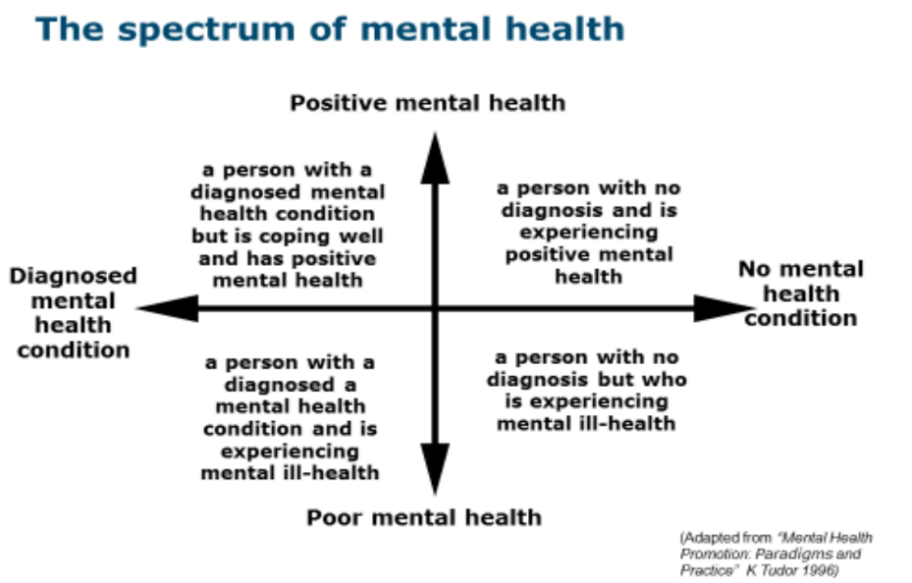
The statutory framework
Under the Equality Act 2010, the University has a duty as an employer and a provider of services to students and service users to consider the impact of nine protected characteristics when carrying out its functions and making decisions: one of these is disability, which explicitly covers mental health conditions. The University therefore has a duty to ensure that it does not discriminate unlawfully against members of its community on the grounds of – or because of factors arising from – mental health conditions and has a duty to consider how to improve equality and good relations between those who experience a mental health condition (disability) and those who do not.
The Stirling Experience
The University recognises its statutory duties in relation to mental health but seeks to go further than simply considering and responding to diagnosed mental health conditions. The University understands the links between positive mental health, performance and success, and is committed to ensuring that all students and staff – as part of a positive “Stirling Experience” - can work, study, research, live and participate in an environment that respects, protects, promotes and enhances their mental wellbeing and supports them to succeed. Whilst individuals are responsible for taking steps to ensure their own mental and physical wellbeing, the University recognises its responsibilities and opportunities as a supportive employer and educator and is committed to identifying and taking steps to address any systemic factors, exacerbators or barriers that might prevent members of our community from achieving optimal mental health.
Our vision for success
Our vision in delivering this strategy is: “We will foster and nurture a culture and environment that respects, protects, promotes and enhances the mental health and wellbeing of our students and staff, enabling them to thrive and achieve their potential whilst achieving our institutional ambitions.
This relies on the creation of an institutional culture which recognises the link between mental health, wellbeing, performance and impact, and which enables our community to talk openly about mental health without stigma or fear.”
What we want to achieve: six strategic objectives
Objective 1: We will make the protection and enhancement of mental health a strategic priority for the institution, through demonstrating leadership, targeting resources, and routinely considering the impact of institutional policies and decisions on the mental health and wellbeing of our students and staff.
We will achieve this by:
- Demonstrating clear, visible leadership and commitment to positive mental health at the highest levels in the institution.
- Ensuring that decisions around financial planning, restructuring, and the shape of the institution are assessed for their impact on mental health & wellbeing.
- Investing in leadership development, ensuring that people management skills – including prioritisation of staff wellbeing, resilience, inclusivity and respect for diversity - are core elements of Stirling leadership values and behaviours.
- Supporting and developing leaders and line managers to become increasingly confident and competent in identifying, discussing and working with their colleagues to prevent and address mental health issues, including during work planning & development discussions.
- Increasing visibility of senior leaders (staff and student) and prominent members of the university family in communications and campaigns on mental health
- Ensuring the mental health strategy is resourced to ensure progress is realistic.

Objective 2: We will embed the protection and enhancement of mental health into institutional policies, working practices, academic programmes and curricula, facilities, the campus and digital environment, and post-Covid reset plans, ensuring that systemic barriers to good mental health are identified and eradicated.
We will achieve this by:
- Ensuring that wellbeing and inclusivity are key enabling principles in institutional post-pandemic reset and regrowth plans.
- Actively promoting and supporting progressive and agile working practices and a healthy work/life balance through visible leadership and role modelling.
- Carrying out evidence-based equality impact assessments during the development/review of policies, procedures, activities and decisions.
- Delivering equality impact training to support our staff to conduct effective EIAs.
- Creating an institutional community of good practice around mental health enhancement and support, including the development of mentally healthy curricula, facilities, environment and progressive working practices.
- Identifying aspects of curriculum design and delivery, including organisation, content and assessment, which unduly exacerbate stress or could be adapted to increase mental health literacy.
Objective 3: We will develop and implement activities, interventions and partnerships which promote and sustain the enhancement of student and staff mental health, particularly focusing on key transition points in the student and staff journey and aiming to build resilience and ownership of our own mental health.

We will achieve this by:

Students
- Introducing "Student Success & Support" contacts in each Faculty to create a "Hub and Spoke" model of support and referral between these and central Student Support Services.
- Developing interactive content on mental wellbeing, lifestyle, resilience and coping skills for inclusion in Stirling Essentials, Welcome & Orientation, and available on Canvas for integration into curricula
- Strengthening the focus on wellbeing and mental health in Personal Tutor and faculty engagement with students
- Integrating the promotion and enhancement of mental health into the employability strategy, graduate attributes and the transition out of university into the workplace
- Creating well promoted, trained and supported points of contact within student clubs and societies to signpost, raise awareness and deliver activities to promote good health and wellbeing
- Delivering mandatory Mental Health Awareness training to Accommodation Liaison Students, Club/Society Officers, Faculty Officers, STEER Mentors and other students in high profile positions

Staff
- Integrating core briefing and guidance on mental health, “red flags” and support/referrals into central HR and local induction and transitions programmes, utilising digital materials where appropriate.
- Delivering a programme of Mental Health Training, with particular focus on line managers and student facing staff.
- Supporting and developing leaders and line managers to become increasingly confident and competent in identifying, discussing and working with their colleagues to prevent and address mental health issues, including during work planning & development discussions.
- Developing a programme of pulse surveys to strengthen our understanding of staff experience and institutional culture.
Both
- Developing and promoting, within the frameworks of “Healthy Body, Healthy Mind” and the “Be Connected” Stirling Life programme, a holistic programme of activities that promote connectedness, social interaction, wellbeing, activity and a sense of community and belonging.
- Developing targeted campaigns and outreach activity to raise awareness of and normalise wellbeing and mental health issues and to promote available support.
- Developing a communications plan to ensure students & staff are aware of the range of proactive wellbeing initiatives in place and support they can access if they are experiencing a decline in mental health.

Objective 4: We will establish a support framework which ensures that students and staff can access mental health support at the appropriate time without experiencing stigma or discrimination, including access to highly skilled, appropriately resourced and well-trained specialist support staff.

We will achieve this by:
Students
- Continuing to invest in high quality student support provision to ensure the University's services can respond effectively to increased student registrations and are able to provide proportionate support throughout the year, including proactive support to safeguard and promote wellbeing and good mental health.
- Strengthening the case management approach to student crises through the implementation of a new Student Hub IT system and associated collaborative protocols around information sharing.
- Building partnerships with identified agencies including NHS, GPs, local authorities and charities to develop a city-wide approach including swift referrals and care pathways.
- Reviewing out of hours crisis response support for students to ensure that the model is optimised, taking account of need, resources and risk.
- Continuing to review Student Support Services registration and triage processes to ensure services are targeted at those most in need and who will benefit from available services.

Staff
- Embedding and enhancing the Employee Assistance Programme and Occupational Health provision, reviewing and responding to evaluation data obtained.
- Reviewing the absence policy and introducing wellness action plans, moving the focus to facilitating attendance at work.
Both
- Developing an institutional suicide prevention and postvention plan

Objective 5: We will ensure staff and students who support students and colleagues experiencing stress or mental ill health can spot the “red flags”, know where to signpost for support, and are sufficiently equipped, trained and supported themselves.

We will achieve this by:
- Optimising support (e.g., trained supervision) for staff who operate in roles where they are supporting students and other staff in crisis.
- Enhancing guidance and resources available for staff supporting students in digital platforms such as Canvas and SharePoint.
- Rolling out the staff and student briefing and training programmes referred to in relation to outcome 3.

Objective 6: We will improve our knowledge and understanding about the mental health and wellbeing of our community and of the impact of this strategy.

We will achieve this by:
- Exploring ways to improve the quality of student and staff data that enhances understanding of mental health and wellbeing, impact of support and perceptions of the University culture.
- Enhancing reports to University Court and Academic Council and increasing opportunities for discussion of the mental health strategy and student/staff wellbeing and resilience.
- Creating opportunities for regular consideration of the mental health strategy and student/staff wellbeing in senior strategy and decision-making fora and committees.
Impact: what success will look like
Staff outcomes
- A culture in which staff feel confident to disclose mental ill health and feel supported by the University.
- A leadership team that demonstrably values, protects and enhances positive mental health amongst their staff.
- A staff team that is confident and competent in assessing the impact of our decisions and activities on mental health and wellbeing
- A workplace culture built on agile, inclusive and progressive working practices which enables staff to sustain a healthy work-life balance whilst achieving optimum outcomes.
- Well-developed understanding and awareness amongst staff about mental health, how to enhance their own, how to support a colleague who needs support, and how to access support.
- A robust and effective Occupational Health and Employee Assistance Programme that responds effectively and timeously to the needs of our staff.
- An institutional culture whereby staff are supported to work and return to work following a period of mental ill health.
- Improved understanding of staff experiences of mental health and support, obtained through a robust evaluation framework.
Student outcomes
- A culture in which students feel confident to disclose mental ill health and feel supported by the University.
- Robust and effective Student Support Services that respond appropriately, effectively and timeously to the needs of students who are experiencing mental health problems.
- Good understanding and awareness amongst staff and student officers about mental health and how to support a student who requires this.
- Good understanding amongst the student body about how to protect and enhance their own mental health and wellbeing and how to access support if needed.
- An institutional culture in which students are supported to study and return to study during and following a period of mental ill health
- A curriculum and assessment framework designed with due regard to the principles of mental wellbeing and inclusivity.
- Campus facilities and a digital environment designed with the promotion of wellbeing and mental health in mind.
How we will measure success
Baseline data and trends will be captured in the supporting monitoring and evaluation framework. Sources of data will include recognised surveys such as the National Student Survey (NSS), Postgraduate Taught Experience Survey (PTES), Postgraduate Research Experience Survey (PRES), staff pulse surveys and the Thriving Learners student survey on mental health. Data will be both qualitative and quantitative as appropriate, and we will utilise proxy data where necessary. The evaluation framework will be overseen by the Health & Wellbeing Group, which is chaired by the Dean of Equality, Diversity and Inclusion and will report progress to University Strategy and Policy Group (USPG), the Equality Steering Group, the Student Experience Committee and Joint Policy, Planning and Resources Committee (JPPRC), Academic Council and University Court.
Implementation and reporting
The Health and Wellbeing Group will oversee the implementation of a an agile, dynamic enabling plan which operationalises the achievement of the strategic objectives.
Values-based guiding principles
Six principles permeate and enable the delivery of the strategy. Regardless of the changing context, environment or relative priority of actions, these principles are sustainable and fundamental to the successful delivery of the strategy.
A holistic, whole institution approach: Creating a culture of collective responsibility for wellbeing and positive mental health in our staff and student community, based on strong partnerships, personal accountability, and collaborative action.
Leadership: Demonstrating committed, inspirational and impactful senior leadership to deliver the strategic vision, whilst simultaneously encouraging, role modelling and rewarding positive leadership behaviours at all levels of the organisation.
Proactivity: Taking proactive action to promote wellbeing and to support students and staff experiencing mental health problems, whilst encouraging our students and staff to proactively take steps to safeguard and strengthen their own mental health and wellbeing.
Evidence based interventions: Using evidence to understand the issues facing our students and staff, design our interventions and demonstrate their impact.
Continuous improvement: Regularly evaluating the impact of our strategy and adapting our approach to build a culture and community of innovative practice and continuous improvement.
Diversity and inclusion: Nurturing and championing a culture of inclusion that supports and encourages our students and staff to succeed, regardless of the presence of mental health conditions, and which recognises and responds to the intersectionality between mental health and other characteristics such as sex, gender identity, ethnicity, disability or sexual orientation.

