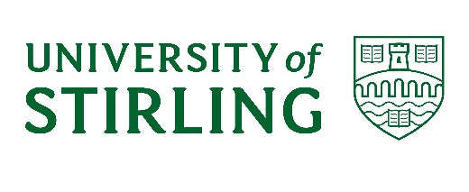
Emeritus Status
- Features
- This status is conferred by the University Court acting under Ordinance 13.

- The Emeritus title is only available to retired Professors and Senior Officers of the University.

- Deans of Faculty are asked to nominate senior academic staff as this status is not granted automatically following a retiral.

- Emeritus status does not provide an automatic entitlement to University resources. Any arrangements for access to University resources is at the discretion of the Dean of Faculty and should be arranged through the faculty.

- Process for requesting Emeritus status of the University
The following steps are required to grant Emeritus status:
- The Dean of Faculty should complete a nomination form (see below) in anticipation of an imminent retiral, requesting that Emeritus status be effective from the date of retiral. The nomination form should include a brief case in support of the nomination and include details of the nominees’ designation/qualifications so this can be recorded in the Calendar if the proposal is approved. The completed form should be sent to Policy & Planning (sacsadmin@stir.ac.uk)

- Nominations are proposed as an item on the Reserved Business agenda of any University Court meeting.

- Once the status has been granted by University Court the minutes are forwarded to the HR & OD Department.

- The HR Service Centre team will then write to the individual advising that Emeritus status has been granted and the HR system will be updated accordingly.

Nominations for Emeritus Professor or other Emeritus positions
Name:

Retirement Date:

Length of Service:

Designation/Qualifications (for Calendar entry in the format BSc (Stirling), PhD (Cambridge)):

Brief summary of career at Stirling and contribution made:

Proposer:

Date of Proposal:

Please keep nominations to one page if possible.

