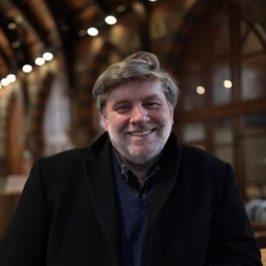

Prof David Johnston

David Johnston is Professor of Translation in the Centre for Translation and Interpreting at Queen’s University Belfast. He has published extensively on the relationship between theory, practice and ethics in the translation process, particularly in terms of translation for the stage, and has given invited lectures and papers to audiences in twenty-eight countries. He is also a multi-award winning translator for the stage, described as ‘the most innovative translator of Spanish Golden Age drama in the twenty-first century’. He is an elected member of the Academia Europaea.

Abstract
Translating the Dead: Solidarity and the Afterlife

David Johnston
Centre for Translation and Interpreting
Queen’s University Belfast

The notion of any afterlife demands the envisioning of another place of habitation. In his “The Task of the Translator” Walter Benjamin famously argues that the “afterlife” of the text resides in its translation, a characterisation frequently pressganged into service as abbreviated form in order to assert the centrality of translation to wider processes of cultural transmission. In this commonly articulated conception, the original is supplanted by the new, an act of displacement that is simultaneously vaunted by those seeking to stake a claim for the power of translation, and disavowed by those for whom the translation can never be more than an original manqué. Benjamin, of course, draws a key distinction – but not absolute separation - between what he terms the “moving truth” and the “resting truth” of the text, effectively eschewing any simple sense of the translation as a product of annexation into the present, and suggesting instead that the new text is constituted by fragments of relation between the “truths” of the source text, historically conditioned and transcendental alike, and the shifting contexts of reception it newly inhabits. In that way, prefiguring as it does Derrida’s articulation of the “survival of a text that is a legacy”, Benjamin’s sense of textual afterlife implies an ongoing presence that is both culturally present and materially absent – as is implied in the apparent paradox of his “translation passes through continua of transformation, not abstract ideas of identity and similarity”. It is with these “continua of transformation” that this talk is concerned, with particular reference to the translation of Spanish theatre.

