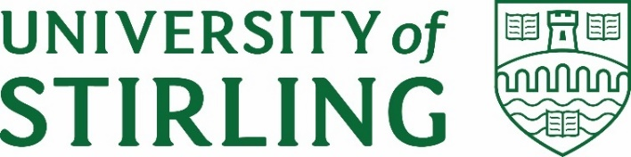
Stirling Law School’s Bulletin 1/2022
This bimonthly bulletin is for sharing Stirling Law School’s achievements in research, teaching, and engagement. In these difficult times, it’s crucial to celebrate, strengthen our sense of community, and create opportunities for cross-Faculty and cross-University collaborations. We hope you’ll enjoy this wee snippet of Stirling Law School’s recent successes.
Contents
Impact and engagement 1
Publications 3
Income generation 5
Employability News and Teaching Excellence 5
Esteem, network, awards, and citizenship 5
Dissemination and media presence 6
Events organised 7
Welcome! 9
Get in touch 9

Impact and engagement
Dr Tracy Kirk has been appointed Appointment to the Scottish Government's Children's Rights Implementation Group for Children in Conflict with the Law. The group contains a range of professionals from across criminal justice and human rights including Police Scotland, Children's Hearings Scotland, the Children and Young People's Commissioner for Scotland.
This group will seek to take forward a number of issues outlined within the Youth Justice Vision. There will be a particular focus on ensuring that those who go through the Criminal Justice System have an experience which is meaningful, participative and rights compliant.
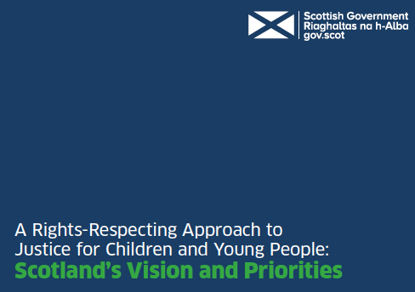
On 6 November Dr Annalisa Savaresi co-hosted an official side event at COP26, titled ‘Litigation, fair share, and the climate responsibilities of governments and fossil fuel companies’, co-organised with the Union of Concerned Scientists and Asociación Interamericana para la Defensa del Ambiente (AIDA).
COP26: Litigation, Fair Share, and the Climate Responsibilities of Govs. and Fossil fuel Companies
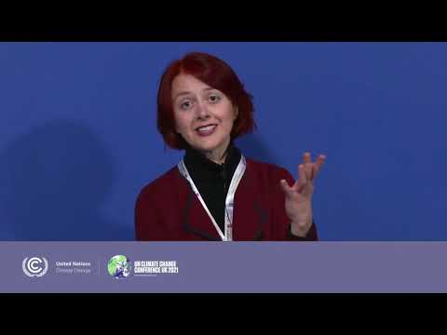
Professor Paul Beaumont is pleased to report that in his role as Chair of the Hague Conference on Private International Law's Experts' Group on Family Agreements he helped to achieve consensus in the Group meetings late last year on the text of a Practitioner's Tool. It is hoped this will become a Soft Law instrument if it is adopted by the Council of the Hague Conference in March 2022.

In December 2021, the House of Commons and House of Lords’ Joint Committee on the Draft Online Safety Bill published a landmark report ‘which will make the tech giants abide by UK law.’ This new law will make internet service providers responsible for what’s happening on their platforms, including for serious crimes like child abuse, fraud, and racist abuse. In Draft Online Safety Bill. Report of Session 2021-22 (HL Paper 129; HC 609, 2021), the Joint Committee has cited extensively expert evidence written by A/Prof Guido Noto La Diega on behalf of the British and Irish Law, Education and Technology Association (BILETA).
In particular, the UK Parliament has referred to Guido’s points about (1) the impact on fundamental rights of delegating to online providers the decision of what content is illegal; (2) the risk that the new law would undermine the privacy offered by end-to-end encryption services; (3) Ofcom’s lack of expertise and the risk that choosing Ofcom as the new online harms regulator would replicate the flawed broadcasting model of regulation; (4) the negative impact on microenterprises with chilling effects on digital competition; (5) the inability of automated moderation technology to understand images in context.

In February 2022, the UK Government’s Intellectual Property Office invited Guido to be part of the initial conversations on how to change UK patent law to improve fairness and interoperability in a hyperconnected world. More information here.

Guido is among the promoters of a campaign aimed at making sure that big pharma companies do not abuse their monopolies to the detriment of a global right to health. In this context, see the Expert Legal Opinion published by the International Commission of Jurists: ‘Human Rights Obligations of States to not impede the Proposed COVID-19 TRIPS Waiver’. Under international human rights law, States have a duty not to obstruct negotiations for a waiver to the Agreement on Trade Related Aspects of Intellectual Property Rights (TRIPS). By opposing the negotiations, as many continue to do, these States fail to perform their treaty obligations under international human rights law in violation of the rights to health, life, equality and science.

Publications
Dr Mo Egan and Professor Hong-Lin Yu have published an article titled Intersecting and Dissecting Confidentiality and Data Protection in Online Arbitration (2022) Journal of Business Law 135-162. This article investigates the conflicting duties of confidentiality and data protection arising from virtual arbitration.
Abstract: While virtual arbitration proceedings are here to stay, cross-border online arbitration has its own challenges in meeting the duties of confidentiality and data protection. Moving arbitration proceedings into a vital world requires awareness of both duties and the potential conflict between them. Examination of the allocation of duties outlined in the Seoul Protocol, the ICCA Protocol on Cybersecurity and the ICCA/IBA Roadmap on Data Protection in International Arbitration this paper highlights the challenges of electronic document storage, trial presentation, extraterritoriality and data transfers and cybersecurity and data protection which should be brought to the participants’ awareness.
Mo's article Remote Justice: Information Rights as a Tool of Empowerment (originally presented at the Bileta Annual Conference 2021) has been accepted for publication in the International Review of Law, Computers and Technology.
Abstract: The coronavirus pandemic has resulted in a compulsory retreat from public spaces. While, for some, this displacement has brought about engagement with digital technologies in new and interesting ways, for others, digital technologies have proved to be the site of technology facilitated abuse (TFA). Consequently, there are renewed calls for regulation of TFA, with a great deal of this discussion focussing on the design and enforcement of criminal law. However, the scope of behaviour perpetrated with, or through, digital technologies is much broader and demands a range of responses that offer access to justice. This paper argues information rights offer significant potential to enable victim/survivors to gain control over personal information, to feel empowered, and to improve their mental health and wellbeing. Firstly, it defines information rights and how they are accessed from an EU perspective. Secondly, it addresses the relationship between legal rights and empowerment in this context. It reflects on if, and how, information rights have been used within the UK specifically, to provide reflections on harnessing their potential. And lastly, explores the viability of advocacy in this area.

Dr Pontian Okoli’s “From Brussels to Addis Ababa – A Contextual and Comparative Analysis of Access to Justice Under Private International Law in Africa”, in The Routledge Handbook on African Law (Routledge 2021) edited by Muna Ndulo and Cosmas Emeziem, was recently published.

The chapter examines relevant institutions and legal frameworks for economic integration with a view to determining whether they can support the sustainable growth of private international law in Africa.

Between October and December Dr Annalisa Savaresi published :
- A post on the blog of the European Society of International Law on the UN Human Rights Council recognition of the right to a health environment
- A co-edited blog post series on Human Rights and COP26 for the Global Network for Human Rights and the Environment:
- A co-authored post on the blog of the European Society of International Law on the current initiatives to seek an international court advisory opinion on climate change
Professor Paul Beaumont and Dr Jayne Holliday are very happy to report that they completed the proofs for their edited book 'Guide to Global Private International Law' today. This book has been two years in the making and they are both looking forward to seeing it come out in print in May this year.

Paul has just received from the Scottish Universities Law Institute (SULI) Council the go ahead to update the standard work on Scots Private International Law with an excellent team of authors, including Jayne and Dr Pontian Okoli, aiming for publication in 2025.

Income generation
The Arts and Humanities Research Council (AHRC) and the German Research Foundation (DfG) have funded a half-a-million-pound UK-German research project about consumer-centric regulation of the Internet of Things (IoT). The UK Principal Investigator of “From Smart Technologies to Smart Consumer Laws: Comparative Perspectives from Germany and the United Kingdom” will co-lead a team of ten researchers and a consortium of four universities (Stirling, Warwick, Osnabrück, Bonn) for three years starting in February 2022. The project will bring to Stirling a postdoctoral research fellow, stakeholder engagement and dissemination events, as well as international mobility and development opportunities. You can read more about it here. See also coverage in Scottish Legal News.

Dr Mo Egan has been awarded a contract to provide research support to the Independent Advisory Group on Emerging Technologies in Policing as part of a Stirling interdisciplinary team (Professor William Webster, Dr Niall Hamilton-Smith, Dr Dianna Miranda, Dr Irena Connon). Perhaps most importantly, the team includes Niamh Mackay who is one of your Masters in Human Rights and Diplomacy graduates and is appointed as a research assistant. This is a short-term project running until April 2022.

Employability News and Teaching Excellence
Professor Paul Beaumont is pleased that the University has agreed to advertise for two replacement and one new post in Scots Law (two at Lecturer Level and one at Senior Lecturer/Associate Professor level).
The posts are an important part of securing the reaccreditation of the LLB at Stirling by the Law Society of Scotland as part of the quinquennial teaching and learning review of Law in the University of Stirling in Spring 2022.

Dr Jayne Holliday has had a busy period preparing the documentation related to the reaccreditation.

Esteem, network, awards, and citizenship
Arletta Gorecka received Honourable Mention Award and Social Media Award for the best poster at the Doctoral Research Award 2021.

Arletta’s article on Defining Privacy in Competition Law Sphere has been nominated for the Student Antitrust Writing Award by Concurrences.

Dr Domenico Carolei was appointed to the Conference Academic Committee for the 15th International Society of Third-Sector Research (ISTR) Conference. The conference will be held in Montréal, Canada, at Concordia University (July 2022). ISTR is an international society that brings together over 700 scholars working on research on civil society, human rights activism, and non-profit studies.
Domenico joined the Goias State University Multidisciplinary Group in Human Rights (Brazil) as a research member.

Based on their record of publications, the Times Higher Education selected Guido Noto La Diega to contribute to the Times Higher Education Global Academic Survey and ‘represent your peers in both your discipline and country.’

Dissemination and media presence
In November 2021, Annalisa Savaresi gave talks on:
- ‘Plugging the enforcement gap.The rise and rise of human rights in climate change litigation’ as part of the Human Rights Council Speaker Series at the University of Essex.
- ‘Human Rights and Climate Litigation’ at the workshop ‘The Role of Human Rights in Phasing Out Fossil Fuels’ held at Copenhagen University.
- ‘The Role of the Right to a Clean, Healthy, and Sustainable Environment in Climate Change Litigation’ at the conference ‘Climate Change Cases Before National and International Courts – Cross-Fertilization and Convergence’ held at Sorbonne University, Paris.
In December and January, she joined the following panels:
- Online workshop ‘Climate Litigation in the Global South’ organised by the GNHRE
- Roundtable discussion on COP26 organised by the Yearbook of International Environmental Law. The recording of the event is available here
- ‘Towards a greening of human rights: What does the right to a healthy environment mean for water resources?’ webinar co-organised by Swedish International Development Cooperation Agency and the Swedish International Water Institute
Guido Noto La Diega has presented ‘Fourth Industrial Revolution and European Intellectual Property Law’ at Intellectual Rights: Challenges of the 21st Century, Tomsk State University, 9-13 November 2021.
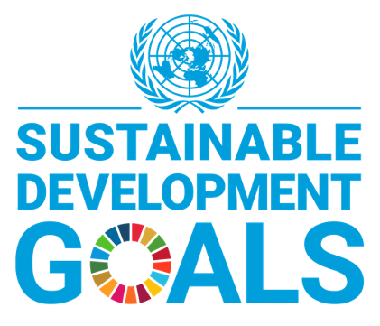

Events organised
We are pleased to announce the 1st edition of the Stirling Law School Human Rights & Public Law Guest Seminar Series 20-21. Three stellar events with eminent guest speakers. We start with a seminar on human rights in Scotland led by Luise Felipe Yanes, Scottish Human Rights Commission. Then, Dr Fareed Hassan (Islamic University of Malaysia) will bring the Asian perspective on the International Criminal Court, looking at human rights atrocities in that region. Grand finale with Prof Thea Hilhorst (Rotterdam University), Dr Maryam Deloffre (Elliot School, Washington DC) and Dr Andrew Cunningham (formerly LSE) who will be debating issues of accountability of aid and development organisations. For further information, contact Domenico Carolei.

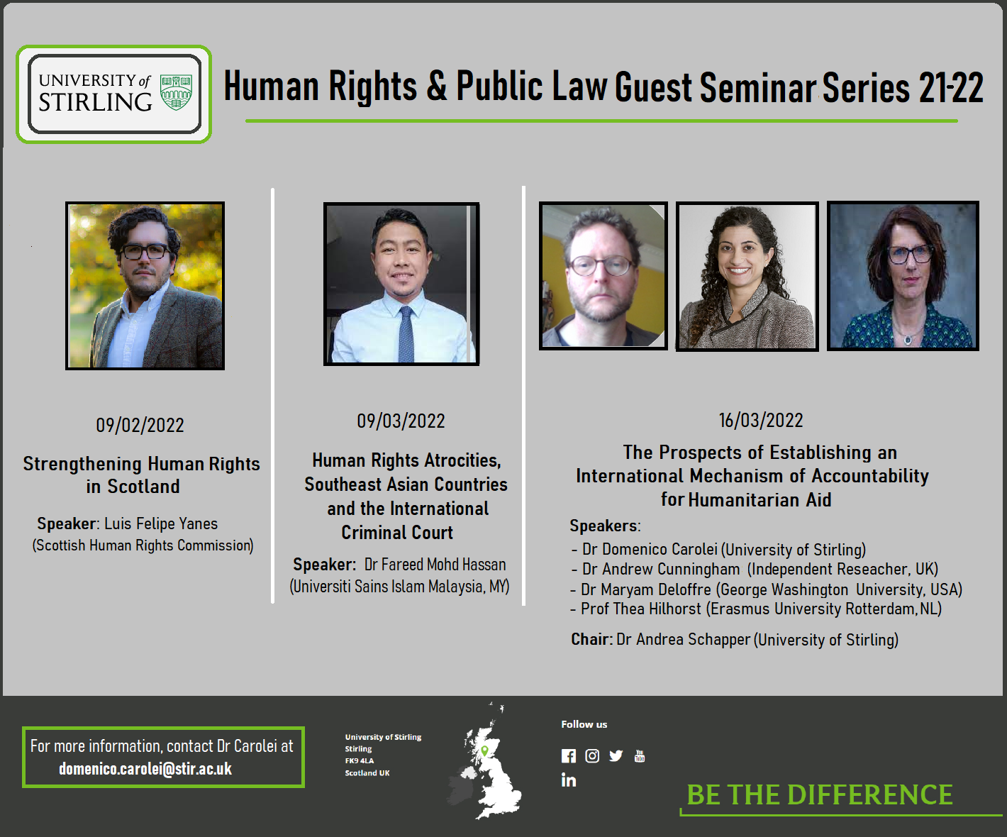

On 5 November, Annalisa Savaresi organised a panel discussion at the Climate Law and Governance Day, held on the sidelines of COP26, at Glasgow University, titled ‘Rising Temperatures, Expanding Human Rights and the Obligations of States and Private Actors for Global Climate Justice’.
Topic I: Rising Temperatures, Expanding Human Rights & the Obligations of States...
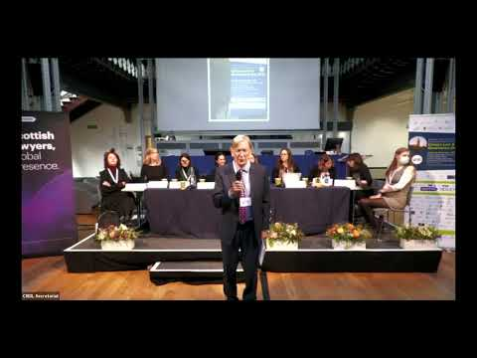

Welcome!
We are delighted to share that three new colleagues have joined the Law School. Our warmest welcome to Dr Zoi Krokida, Dr Edit Frenyó, and Dr Elizabeth Brandon! They will contribute to impactful research and excellent teaching in the areas of Intellectual Property, EU Law, Child and Family, Environmental Law, and Delict.

Get in touch
If you would like to contribute or suggest anything for future bulletins, please get in touch with Guido.

