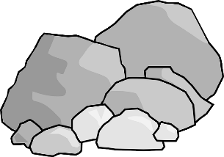 | Cowie and Plean Rock Trail
Follow the Cowie to Plean cycle/walking path and keep an eye out for the painted rocks on the fence and gate posts, in the trees, on the walls, and on the ground. Some are close together along the route, and some are far apart. Answer the questions below but remember there are a lot more to spot, so keep alert. Tally up how many you find.

- What colour are the miners’ helmets?
- Can you name the miners’ tool?
- What did the miners use for light
- What colours are the flower petals, and can you name the flowers?
- From the darkness, -------- the -------- Fill out the missing words.
- -------- for the ------- Fill out the missing words.
Keep a tally of all the rocks you find, by putting mark in the box. Then add them all up

Total number of rocks---------

