ECSSS Annual Conference 2025: Scots and the Environment
Pathfoot Building, University of Stirling, 17–20 June 2025



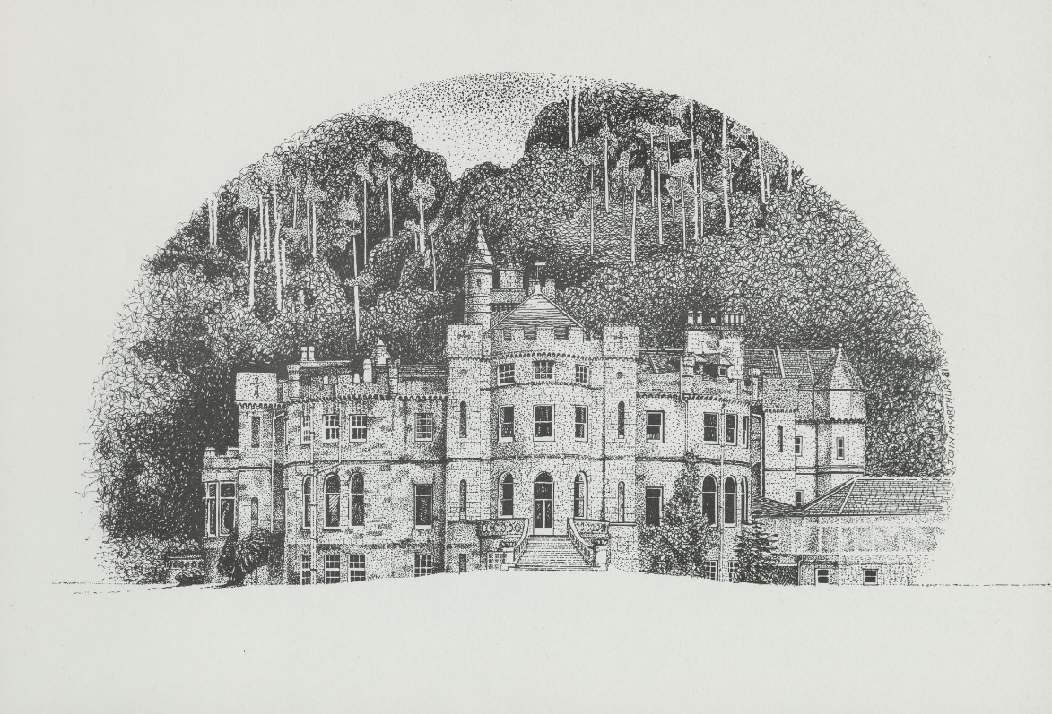

Airthrey Castle. John McArthur, 1981.
University of Stirling Archives.

ECSSS Annual Conference 2025, University of Stirling: Scots and the Environment

Local knowledge

Please accept a warm welcome to the University of Stirling and the Stirling area!

Here are some links we hope you may find helpful in navigating the campus, and finding places to eat in the evenings:

Maps and travel
https://www.stir.ac.uk/about/getting-here/

Local restaurants
Where to eat and drink in Bridge of Allan — Discover Bridge of Allan

https://www.themeadowparkstirling.co.uk/

8 Quirky Places to Eat in Stirling | VisitScotland

Campus swimming pool and gym

Please check the Sports Centre website for events which may mean that these are closed. Otherwise, if you’re staying on campus in the hotel or Willow Court, you are welcome to use these facilities free of charge.

Programme at a Glance

Tuesday 17 June

1pm: Registration (Crush Hall)
2pm: Welcome (Pathfoot Lecture Theatre)
2.15–3.45pm: Keynote lecture: Richard D. Oram (Pathfoot Lecture Theatre)
3:45pm: Tea (Crush Hall)
4-6pm: PGR Lightning Talks (Pathfoot Lecture Theatre)
6-7:30pm: Gin Exhibition (room D3)
7:30pm: Dinner (own plans)

Wednesday 18 June

9-10:30am: Panel Session A (rooms D1, D3, C22 and C23)
10.30–11am: Coffee (Crush Hall)
11am–12.30pm: Panel Session B (rooms D1, D3, C22 and C23)
12.30–1.30pm: Lunch (Pathfoot Dining Room)
1.30–3.30pm: Panel Session C (rooms D1, D3, C22 and C23)
3.30–4pm: Tea (Crush Hall)
4–5.30pm: Keynote lecture: Noelle Dückmann Gallagher (Pathfoot Lecture Theatre)
5.45–6.30pm: ECSSS AGM (Pathfoot Lecture Theatre)
6.30–7.30pm: Concert (Pathfoot Lecture Theatre)
7.30pm: Dinner (own plans)

Thursday 19 June

9–10.30am: Panel Session D (rooms D1, D3, C22 and C23)
10.30–11am: Coffee (Crush Hall)
11am–1pm: Panel Session E (rooms D1, D3, C22 and C23)
1–2pm: Lunch (Pathfoot Dining Room)
2–3.30pm: Keynote lecture: Gerard Lee McKeever (Pathfoot Lecture Theatre)
3.30pm: Expeditions to the Leighton Library (by coach), or to historic Stirling (walking tour)
7.00pm: Conference Dinner: Stirling Court Hotel (on campus)

Friday 20 June

Friday 9–11am: Panel Session F (rooms D1, D3, C22 and C23)
11–11.30am: Coffee (Crush Hall)
11.30am–1pm: Panel Session G (rooms D1, D3, C22 and C23)
1.00pm: Travel to Blackie House Library, Edinburgh

Full Programme

Tuesday 17 June
From 1pm Registration: Crush Hall

2pm Welcome (Emma Macleod, Katie Halsey): Pathfoot Lecture Theatre

2.15–3.45pm Keynote lecture: Richard D. Oram, ‘We Need to Talk about “Improvement”: An Environmental History Perspective on “Improvement Era” Scotland’ (Chair: Emma Macleod): Pathfoot Lecture Theatre

3.45pm Tea: Crush Hall

4–6pm PGR Lightning Talks (Chair: Michael Brown): Pathfoot Lecture Theatre

6–7.30pm Gin Exhibition: room D3

7.30pm Dinner (own plans)
ECSSS Board Dinner and Meeting

Wednesday 18 June

Wed. 9–10.30am Panel Session A
Panel A1: Travel (Chair: Eric Gidal): room D1
Catherine Jones, ‘Foreigners in Muscovy and the Hetmanate in a Time of War and Popular Revolt (c. 1655–c.1721)’
Matthew Lee, ‘From Seascape to Landscape: Travel, Environment and Scottish Perceptions of Colonised Places’
Pam Perkins, ‘Northern Environments: Charles Fothergill's Travels in Orkney and Shetland’

Panel A2: James Hutton and David Skene (Chair: Mark Spencer): room D3
Adrian Shaw, ‘Why no shock and horror? The Response of Church of Scotland Ministers to James Hutton's Theory of the Earth’
Gregory Todd, ‘James Hutton: Philosophical Improver, Theorist of the Earth’
Bradford Bow, ‘“David Skene’s “Study of Mankind” and Natural History in the Wise Club’

Panel A3: Roundtable: David Hume’s Account of James VI & I (chair: David Raynor): room C23
Pamela Ahern
Alasdair Raffe
Jean-François Dunyach

Panel A4: From Boswell to Muir through Politics (chair: Emma Macleod): room C22
David Purdie and J. N. Davie, ‘Classical Quotation and Allusion in James Boswell’s Life of Samuel Johnson’
James J. Caudle, ‘Making Sense of James Boswell’s Politics’
Rémy Duthille, ‘The Forgotten Hero? The Reception of Thomas Muir (1765–1799) in France’
10.30–11am Coffee: Crush Hall

Wed. 11am–12.30pm Panel Session B
Panel B1: Urban and Garden Improvements (Chair: Rosamund Paice): room D1
Anthony Lewis, ‘In the Name of Improvement: Planning and Building New Cities, Harbours and Transport Systems, and their Impacts on the Environment’
Alex Benchimol, ‘“The foremost commercial city in Scotland”: Constructions of an Industrial Urban Environment in the Glasgow Advertiser, 1783–1800’
Camilla Allen, ‘A Most Enlightened Structure: Sir James Hall’s Arboreal Architecture’

Panel B2: Family, Food and Credit (Chair: Florence Petroff): room D3
Jocelyn Zimmerman, ‘“Into the Hilly Country”: Hills, Sexuality and Kinship in Eighteenth-Century Expeditions of Discovery’
Lucy Henry, ‘‘The extreme dearth and scarcity of the times’: Food Scarcity and Crime in the Inverness Sheriff Court, 1782–4’
Leïla Cheurfa, ‘Environment and Credit Relations in Eighteenth-Century Scotland’

Panel B3: Text and Environment (Chair: Gerard Lee McKeever): room C23
Michael Gavin, ‘Scottish Geoinformatics: Sir John Sinclair and the Statistical Account of Scotland’
Siobhan Carroll, ‘James Hogg and the Demons of Improvement’
Eric Gidal, ‘Design with Nature: Sir John Sinclair to Ian McHarg’

12.30–1.30pm Lunch: Pathfoot Dining Room

Wed. 1.30–3.30pm Panel Session C
Panel C1: Built Environment (Chair: Camilla Allen): room D1
Ann V. Gunn, ‘Paul Sandby’s Formative Depictions of Scotland’s Buildings’
Reva Wolf, ‘Architecture as Nature and Nation: Rosslyn Chapel in Word and Image, 1761–1830’
Samantha Carrie, ‘The Role of Painting in William Henry Playfair’s Development of the Urban Picturesque’
Clarisse Godard Desmarest, ‘The Early Work of William Burn: Style and Identity in Urban Scotland, c. 1810–1830’

Panel C2: Jacobites (chair: Leith Davis): room D3
Kang-yen Chiu, ‘Sir Robert Strange, His Print Works and the Jacobite Cause’
Michael Ray Taylor, ‘Charlwood Lawton and Whiggish-Jacobite Latitudinarianism’
Alanna MacTavish, ‘A House Divided: Factionalism and the Fall of a Jacobite Education’
Calum Cunningham, ‘Jurisdictional Overreach? Prosecuting Treason in the post-Union Scottish Legal Environment, 1708–48’

Panel C3: Coal, Sea, and Horses (chair: Katie Halsey): room C23
Robbie Tree, ‘The Collier, the Natural Philosopher and the Black, Black Gold: Sustainability and Environmental Thought in the Eighteenth-Century Scottish Coal Fields’
Scott McFie, ‘Coal and the Agricultural Revolution in Central-West Scotland, 1750–1815’
Florence Petroff, ‘The Society of Antiquaries of Scotland, the Sea, and Improvement’
Miriam Bibby, ‘From “Golden Age” to “totally worn out” and vanishing from the landscape: the changing fortunes of Scotland’s Galloway Nag in the Eighteenth Century’
Panel C4: ‘Tyrannic man's dominion’: Earth, Environment, Ecology and Robert Burns (chair: James J. Caudle): room C22
The Centre for Robert Burns Studies, University of Glasgow
Ronnie Young, ‘Composing in August: Ecology and Dominion in Burns’s Early Verse’
Nigel Leask, ‘“Gie mi ae spark o' Nature's fire”: Robert Burns and Climate’
John Watson, ‘‘‘Her Mantle large, of greenish hue”: Robert Burns and the Bioregional’
Matt Rowney, ‘Holding the Thread at Both Ends: Robert Burns as Industrial Tourist’

3.30–4pm Tea: Crush Hall

4–5.30pm Keynote lecture: Noelle Dückmann Gallagher, ‘The Rise and Fall of “Scotch Itch”: Disease and the Environment in Eighteenth-Century Scotland’ (Chair: Katie Halsey): Pathfoot Lecture Theatre

5.45–6.30pm ECSSS AGM: Pathfoot Lecture Theatre
Presentation of the ECSSS Lifetime Achievement Award to Leith Davis

6.30–7.30pm Concert: Pathfoot Lecture Theatre
Jennifer Reid
Brianna Robertson Kirkland and Jacques Carroll-Leitao

7.30pm Dinner (own plans)

Thursday 19 June

Thurs. 9–10.30am Panel Session D
Panel D1: The Clarendon Edition of Hume’s History of England: Observations and Preliminary Findings: a roundtable: room D1
Mark Spencer
Marc Hanvelt
Mikko Tolonen

Panel D2: Leisure (Chair: Emma Macleod): room D3
Brycchan Carey, ‘From Scotia Illustrata to The Statistical Accounts: Scottish Clerical Naturalists in the Long Eighteenth Century’
Edward Hardiman, ‘‘The mischiefs of misapplied activity’: Improvement, Industriousness, and Idleness in The Lounger’
Brianna Robertson-Kirkland, ‘How the Corris influenced Edinburgh’s Musical Environment’

Panel D3: Women Writers (chair: Moira Hansen): room C23
Katie MacLean, ‘Jane Austen in Scotland’
Carmen-Veronica Borbely, ‘Distilled Ecologies: Elizabeth Hamilton’s Sense of Place’
JoEllen DeLucia, ‘Frances Wright and the Scottish Enlightenment: Defining Women’s Progress’

Panel D4: Adam Smith and James Beattie (chair: James Harris): room C22
Craig Smith, ‘Adam Smith’s Lectures on Natural Religion: Re-constructing what he might have said’
Eugene Heath, ‘The Tragic Sense of Adam Smith’
Michael Brown, ‘James Beattie's Political Thought’
10.30–11am Coffee (Crush Hall)

Thurs. 11am–1pm Panel Session E
Panel E1: Empire and Race (Chair: Paul Tonks): room D1
Nicola Martin, ‘Scots and the Imperial Environment: James Murray, “improvement” ideology, and imperial governance in Canada’
Gioia Angeletti, ‘Narratives and Images of Other Places and People: Lady Anne Barnard and the South African Environment’
Thomas Tyson, ‘“Gypsies” and the Transformation of the Scottish Landscape, 1770-1815’
Suchitra Choudhury, ‘Sir Walter Scott and Paisley Shawls: Fiction, Industry, Empire’

Panel E2: Poetry and Environment (Chair: Pam Perkins): room D3
John Watson, ‘Sublime Ecologies in James Thomson’s The Seasons’
Amy Wilcockson, ‘“Auld Reikie’s unofficial laureate”: Robert Fergusson and Scotland’
Rosamund Paice, ‘A Very English Eden: Echoes of Stephen Switzer in Sir John Clerk of Penicuik’s ‘The Country Seat’
Ellen Beard, ‘The Music of Gaelic Nature Songs’

Panel E3: Science (Chair: Noelle Dückmann Gallagher): room C23
Tamás Demeter, ‘Humean Chemistry’
Jeffrey Wolf, ‘On (Scottish) Airs, Waters, and Places: Dr. William Cullen’s (1710-1790) Rules for the Preservation of Health’
Alasdair Raffe, ‘The Environment of Natural Philosophical Debate in Newtonian Scotland’

Panel E4: The Birth-Place of Value, the Country of Wealth: Improvement Policies in the Long Eighteenth Century and their Environmental Legacies in the Scottish Highlands (chair: Jean-François Dunyach): room C22
Thomas Archambaud, ‘‘Improvers and backbenchers: the Macphersons, East India Company capital and the improvement of nature, 1780-1821’
Tom Pye, ‘Rethinking the Origins of ‘Liberal’ Political Economy: Adam Smith, Enclosure, and Feudal Land Law’
Juliette Desportes, ‘The Moral Ecologies of Improvement: the Forfeited and Annexed Estates (1745-1782)’

1–2pm Lunch (Pathfoot Dining Room)

2–3.30pm Keynote lecture: Gerard Lee McKeever, ‘Regionalism and the Logic of Improvement in Eighteenth-Century Scotland’ (Chair: Matthew Sangster): Pathfoot Lecture Theatre

3.30pm Expeditions to the Leighton Library (by coach), or to historic Stirling (walking tour)

7.00pm Conference Dinner: Stirling Court Hotel (on campus)

Friday 20 June

Friday 9–11am Panel Session F
Panel F1: Translation and Memory (Chair: Emma Macleod): room D1
Paul Tonks and John Frankl, ‘‘Translating Scottish Authors for Korean Readers: Intellectual and Literary Legacies of Eighteenth-Century Scotland in Korea’
Beatriz Leitão, ‘There and Back Again: Unearthing the Rural Memory of the Scottish Highlands through the Bothy’

Panel F2: Readers and Writers (Chair: Michael Gavin): room D3
Jacqueline Imrie, ‘Scots, Libraries, and the Socioeconomic Environment: Orkney’
Josh Smith, ‘Reading and Writing the Land: Readers, Writers and Farmers at the Leighton Library, Dunblane, 1780–1830’
Michael Ratnapalan, ‘Robert Louis Stevenson, Religion, History, and Scottish Political Economy’

Panel F3: Environments of Remembrance (Chair: JoEllen DeLucia): room C23
Pamela Ahern, ‘Complicating Memories of Britain’s Queens in David Hume’s History of England’
Tanner Ogle, ‘Ruins & Remembrance: Jacobite Impressions on the British Environment’
Bonnie Soper, ‘Covenanter Memory, the Construction of Sacred Sites, and the Scottish Landscape’
Leith Davis, ‘Memories of the Environment and Environments of Memory in Robert Forbes’s “The Lyon in Mourning”’

11–11.30am Coffee: Crush Hall

Friday 11.30am–1pm Panel Session G
Panel G1: Books & Borrowing (Chair: Josh Smith): room D1
Katie Halsey, ‘Demonstration of the “Books and Borrowing” Database’
Matt Sangster, ‘Re-Framing the Scottish Literary Environment, 1750–1800’
Cleo O’Callaghan Yeoman, ‘Feminist Librarianship: Female Borrowing Patterns in the Books and Borrowing Database’

Panel G2: Thomas Innes (Chair: Gregory Todd): room D3
Kelsey Jackson-Williams, ‘Thomas Innes and His Books’
Dylan Fowler, ‘“A pen dipped in vinegar and gall”: George Buchanan, Thomas Innes, and the Deposing Doctrine’
Clotilde Prunier, ‘The Not so Discrete Personas of Thomas Innes’

1.00pm Travel to Blackie House Library, Edinburgh for those who have booked this option: Visit kindly hosted by Bill Zachs.

