 | Pregnancy and new mother’s Risk Assessment Form
Created/Revised by: |  | 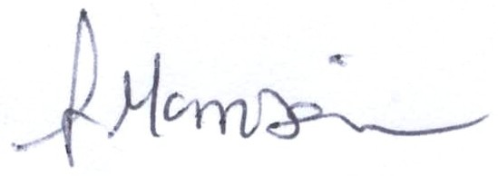 | Effective Date:31/05/22 | Rev -A

Location : Department:

Employee’s name | Job Title/ description of tasks | Date of  Assessment
 |  | Assessment No.

No | Hazards identified | Y | Existing controls | Severity | Likelihood | Risk Rate | Significant  Yes / No |  | Persons at Risk  & Nos. | Further Action Required (see Action Plan) | Residual risk acceptable
1 | Assaults/ violence
2 | Biological hazards
3 | Chemical hazards (COSHH)
4 | Display Screen Equip. (DSE)
5 | Fire
6 | Manual handling
7 | Noise
8 | Posture, stand, sitting, stairs
9 | Pregnancy related issues
10 | Radiations (x-rays etc.)
11 | Rest facilities/ fridge
12 | Shift work, travel, excessive hours
13 | Shocks, movements & vibration
14 | Smoking, passive smoking
15 | Stress, fatigue
16 | Temperature extremes
17 | Working at heights
18 | Working alone
19 | Awkward spaces/ workstation layout
20 | Other (not incl. above)

Assessors’ Signature: Employees Signature: Manager’s Signature: Date:

 | Pregnancy and new mother’s Risk Assessment Action plan
Created/Revised by: |  |  | Effective Date: 31/06/22 | Rev - A

Location : Department:

Employee’s name | Job Title/ description of tasks | Date of  Assessment
 |  | Assessment No.

Activity / Work Hazard | Action to be taken | Person(s) responsible | By when? | Completed  Signature Date

Discussion Record
Has the employee been referred to their own doctor or to Occupational Health?

Assessors’ Signature: Employee’s Signature: Manager’s Signature: Date:

