

Garden of Time
Memorial Guidelines
[EXTERNAL DOCUMENT]

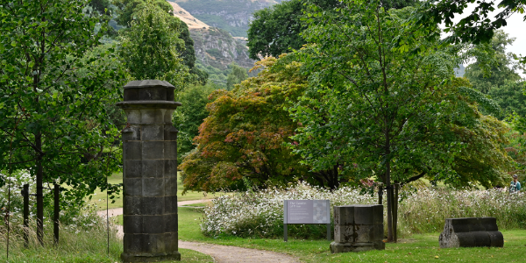
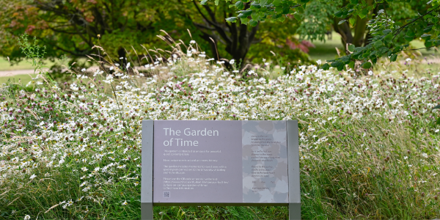

Table of Contents

Scope 3
Location of the Garden of Time 3
Eligibility 3
Memorial Options 4
Memorial Option 1: Plaque on Metal Archway 4
Memorial Option 2: Sculptural Stake 4
Memorial Option 3: Half Caithness Paving Stone (Stone path in Garden of Time) 4
Memorial Option 4: Full Caithness Paving Stone (Stone path in Garden of Time) 4
Memorial Option 5: Bespoke Sculpture 4
Exclusions 5
Memorial Installation Process 5
Memorial Request Process 5
Payment 6
Installation Schedule 6
Sculptural installations – transfer of ownership 6
Historic memorials 7
Equality, Diversity, and Inclusion considerations 7
Terms and conditions 7
Frequently Asked Questions (FAQs) 8
Appendices 11
Appendix 1: Memorial examples 11

Scope
The University of Stirling supports the principle of allowing memorials on its campus. However, we are mindful that our grounds and facilities are enjoyed by a wide range of people. Therefore, the application of this principle will be respectfully applied and managed for the mutual benefit of all. Memorials will be installed in the Garden of Time in line with these guidelines, which are subject to change at any time at the discretion of the University, and will be maintained within reason for a period of ten years. Following this period, memorials may be removed due to damage or lack of space. The scattering of ashes on campus is not an offering we support.
Please direct any enquiries to philanthropy@stir.ac.uk.

Location of the Garden of Time
Once on campus, follow Hermitage Road and you will find the Garden of Time next to Alexander Court and opposite the Airthrey Golf Pavilion.
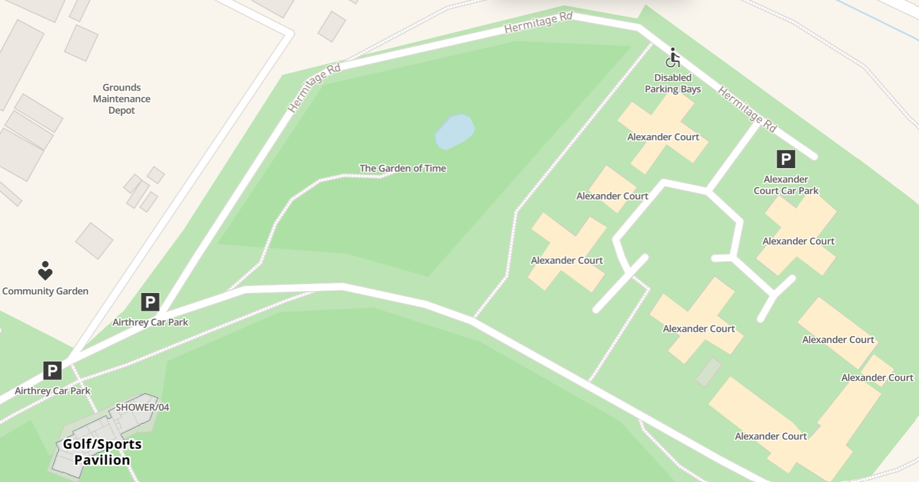
Search ‘Garden of Time’ on the University’s interactive Campus Map for directions.
Find the entrance using the unique What3words combination: ///plotted.clays.directors

Eligibility
Requests for memorial plaques will typically be accepted where the person being remembered has a direct association with the University. For example:
- A current or retired member of staff
- A current or former student
- An Honorary Graduate
- A member of the community with a significant contribution or connection to the University
The University has the discretion to accept other requests, if it is deemed to be appropriate. Exceptions must be authorised by the Director of Development and Alumni Relations, who will consult with relevant colleagues as necessary.

Memorial Options
To ensure the consistency of memorials around our campus and enable staff to deliver an efficient and high-quality service to the families and friends of those being remembered, the following options are available:

Memorial Option 1: Plaque on Metal Archway
- Plaque placed on metal archway within the Garden of Time
- Plaque material: copper (weather resistant)
- Size: 158mm x 52mm x 1.5mm
- Background: Black
- Option of one artwork from a choice of five (see appendix 1)
- Up to 70 characters of white engraved text (Calibri font size 12)
- Fixing: Bonding adhesive backing
- The cost to instruct this option is £300, inclusive of VAT

Memorial Option 2: Sculptural Stake
- Sculptural Andrea Geile stake placed within the Garden of Time
- Stake material: Steel
- Approximate size: 180mm x 80mm x 1.5mm (leaf-shaped, see appendix 1)
- Up to 50 characters of engraved text (Calibri font size 12)
- Fixing: Decorative wire attached directly to stake
- The cost to instruct this option is £400, inclusive of VAT

Memorial Option 3: Half Caithness Paving Stone (Stone path in Garden of Time)
- Half Caithness Paving Stone situated within the Garden of Time
- Size: 600mm x 400mm
- Inscription carved by stonemason
- Up to 70 characters of white engraved text (Calibri font size 16)
- The cost to instruct this option is £800, inclusive of VAT

Memorial Option 4: Full Caithness Paving Stone (Stone path in Garden of Time)
- Full Caithness Paving Stone situated within the Garden of Time
- Size: 1200mm x 400mm
- Inscription carved by stonemason
- Up to 100 characters of white engraved text (Calibri font size 16)
- The cost to instruct this option is £1,500, inclusive of VAT

Memorial Option 5: Bespoke Sculpture
- Bespoke Sculpture (in agreement with University Collections)
- Details including size, location and recognition to be confirmed in discussion with Head of University of Stirling Collections
- The cost to instruct this option is upwards of £4,000, inclusive of VAT. This is dependent on the sculpture chosen and installation requirements. The sculpture and cost will be confirmed after a discussion with the Head of University of Stirling Collections.

Exclusions
Please note the following exclusions to our memorial offering:
- Memorial Benches: We no longer offer the option of benches due to limited space around campus, their susceptibility to wear over time and potential for vandalism.
- Tree Planting: Due to the strict management of trees across our campus and the potential for damage due to factors outwith our control, such as extreme weather or disease, we are no longer able to offer tree planting as a memorial option.
- Flowers or Planting: We do not permit flower holders, flowers or other items to be left on site. The grounds team work hard to maintain our beautiful campus and unfortunately are unable to manage flowers that are left beside benches or trees, which then impacts the campus environment for others in our community. For the same reason, we are unable to allow anyone to plant or maintain their own planting beside a memorial.
- Plaque Inscriptions: To maintain consistency and in keeping with our memorial guidelines, plaque inscriptions follow a set format and are limited to the approved options. As such, they should not include personal dates such as birth, passing, or graduation years.
- Scattering of Ashes: We do not permit the scattering of ashes in the Garden of Time. This decision is made to protect the Garden’s ecosystem, as ashes can alter soil composition and pH, potentially harming plant life or causing damage to the Garden’s structures. The Garden is also used for student research, including soil sampling and environmental studies, and we must ensure these activities are not disrupted. For the same reasons, the scattering of ashes is not permitted elsewhere on campus.
- Naming of Projects, Rooms or Buildings: Requests to name projects or university-owned buildings are reviewed on a case-by-case basis. For more information, please refer to our ‘Philanthropic Naming Policy and Procedure’, which is available upon request. This policy outlines the University's approach to naming projects, initiatives, capital projects, or buildings, which falls outside the scope of these guidelines.

Memorial Installation Process

Memorial Request Process
To request one of the above options in memory of a friend, family member or loved one, please follow these steps:
- Please visit the Garden of Time webpage, which includes important information and the form to make your request. This should be sent to the Development and Alumni Relations team via philanthropy@stir.ac.uk. If you are already in contact with another member of staff at the University, we will be happy to work closely with them too.
- Once we have received your request and checked that we can deliver it in line with these guidelines, we will confirm the details of the request and our bank details (also listed below), so you can make the payment.
- Once you have made your payment, we will record the details on our alumni and supporter database in line with our data protection policy.
- We will then work with colleagues to arrange for the engraving and installation of the item you have chosen. This can take some time due to the multiple steps involved in the process and we have outlined some indicative timescales below.
- We will communicate the progress of the request as appropriate, and will confirm the location of the item once installation has been completed.

Payment
Following the approval of the request, any associated payment to the University must be settled in advance. The Development and Alumni Relations team will contact you to confirm the details of your request and provide our bank information (detailed below) for the transfer of funds. We are unable to proceed without the clearance of funds in advance.
Bank Details
Bank | HSBC UK
Account Number | 63000095
Sort Code | 40-41-60
Reference: | Garden of Time/Requester’s Surname

Installation Schedule
Memorial installations are scheduled to take place three times per year: March, July, and November. Requests should be submitted through the Development and Alumni Relations team by the end of the ‘request deadline’ month outlined in the table below. Occasionally, there are instances where we are not able to install an item during the intended installation month. If this happens, we will do our best to communicate with you as early as possible, so you are aware of the situation.
Request Deadline | Installation Month
January | March
May | July
September | November

Sculptural installations – transfer of ownership
The University of Stirling Collections will add artworks that are installed in the Garden of Time as memorials to the University Art Collection. These works will become part of an accredited museum collection, and a separate transfer of ownership form will be required to be completed.
Please note, it is possible to donate art works or funds to support the work of the University of Stirling Collections. However, the Collections has a collecting policy that limits those items it may acquire. Therefore, not all offers of loans, gifts, legacy donations or sales may be accepted. Any offer of a donation must be approved in the first instance by the Art Collection Advisory Group. To discuss further, please contact the University of Stirling Collections via art.collection@stir.ac.uk.
Please note that stakes, plaques and paving stones are property of the University. The University reserves the right to remove these after the ten-year period.

Historic memorials
There are a significant number of memorials across campus that were installed historically and, as a result, do not align with these revised guidelines. The University Estates and Campus Services team, along with University Collections and the Development and Alumni Relations team, continue to monitor the condition of all memorials and will attempt to contact the original requester before any remedial action is taken.
After a memorial has been in place for ten years, the University reserves the right to remove it if it has become damaged or if space constraints require. Wherever possible, we will make every effort to contact the original requester to offer the option of replacing the memorial item at their own cost and in accordance with the latest guidelines. If we are unable to make contact, the University may proceed with removal after the ten-year period without replacement.

Equality, Diversity, and Inclusion considerations
Access to the Garden of Time
- Please note that access to the Garden of Time is via a gravel path near Airthrey Castle on campus.
Payment options
- Should you be unable to make an online payment then (by exception) a cash or cheque payment may be processed by our Finance Directorate. This will need to be agreed in advance with the Development and Alumni Relations team.
Submitting requests
- Should you be unable to submit our online form then you may contact the Development and Alumni Relations team on 01786 467250 or philanthropy@stir.ac.uk to make your request manually.

Terms and conditions
Given the sensitivity of requesting a memorial, the following terms and conditions are designed to ensure transparency and understanding before you proceed. Please read them carefully.
Payment
- The requester agrees to pay the full cost of the memorial. Payment must be made once the Development and Alumni Relations team has approved the request and before any memorial is arranged.
Location
- The final decision on the exact location of the memorial rests with the University.
Memorial options
- The requester accepts one of the standardised memorial options outlined in this document. No additional embellishments, memorial offerings, flowers, or gifts may be left at the memorial location.
Liability
- The University accepts no responsibility for future loss, damage, or vandalism of memorials. Should any of these unfortunately occur, then the University will offer the requester the option to pay for repair or a replacement.
Relocation
- On occasion, memorial plaques or sculptures may need to be respectfully moved by our Estates and Campus Services team or contractors for building works and/or repairs. Should this occur, the University will make reasonable efforts to contact the requester and inform them of the new location.
Contact information
- It is the requester’s responsibility to inform the University of any change in contact information. The University will make reasonable efforts to contact the requester should an issue arise. If contact cannot be made, actions taken by the University under the terms and conditions will be final and not subject to appeal.
Request Approval
- The University reserves the right to decline any memorial request that falls outside the scope of our Memorial Guidelines. If a request is declined, this will be communicated respectfully and as soon as possible.
Ownership and duration
- Ownership of the memorial item rests with the University. Memorials may be removed after ten years due to damage or space limitations. Wherever possible, the University will endeavour to contact the requester before action is taken to offer the option of replacing the memorial at the requester’s own cost and in line with current guidelines.
Data protection
- The University will hold data provided by the requester securely on our alumni and supporter database. To read more about how your data will be stored, who has access to it, and how it will be used, please read our Privacy Statement.
Accuracy of information
- The requester declares that all information provided is true and accurate, and that the validity of the information provided may be cross-referenced with University records or staff.

Frequently Asked Questions (FAQs)
1. Can I add my own installation or memorial in the Garden of Time?
We understand how important it is to honour your loved one, and we recognise your wish to create something personal. Unfortunately, we are unable to accommodate individual installations outside of the memorial options we provide. This ensures that all memorials remain consistent with the design and integrity of the Garden, as well as ensuring that we can maintain the Garden as a place of reflection for our whole community. We hope one of the options available will provide the right way for you to express your sentiments.
2. Can ashes be scattered in the Garden of Time?
We understand that you may wish to scatter a loved one’s ashes in the Garden of Time, and we truly appreciate the sentiment behind this request. However, to protect the Garden’s delicate ecosystem, we are unable to allow this. Ashes can alter the soil’s composition and pH levels, which may affect plant life and the Garden’s features. The Garden is also used respectfully for student research, including soil sampling and environmental studies, and we must ensure these activities are not disrupted. This also applies to the whole of the campus site and grounds.
3. How long will my memorial be displayed?
Memorials in the Garden of Time are displayed for a period of ten years. After this time, the University reserves the right to move or remove the memorial as required due to damage or space restrictions, and we will endeavour to inform you in advance if any changes are necessary. Please be assured, we aim to preserve memorials with the utmost respect throughout their time on campus.
4. Can I choose the exact location for my memorial?
While we aim to place memorials in meaningful locations, the final placement is determined by the overall layout of the Garden and practical considerations. Each memorial is thoughtfully positioned to ensure it fits harmoniously within the space.
5. Are there any restrictions on the text or symbols used for the memorial?
To maintain a consistent and respectful appearance across all memorials, we implement guidelines. Text on plaques is limited to either 70 or 100 characters, depending on the option chosen, and birth or death dates are not included. This helps to ensure that all tributes remain in keeping with the Garden’s design.
6. What happens if the memorial is damaged?
We take great care to preserve and maintain all memorials. However, in the unfortunate event of damage, we will attempt to contact you to discuss repair or replacement options, which may involve an additional cost. Please be assured that each memorial is treated the utmost care and respect.
7. Can I request a specific artwork or design for the memorial?
We offer a range of carefully selected designs to ensure consistency and harmony within the Garden. However, if you are seeking something more personal, you may explore the bespoke sculpture option for a unique tribute. Please note that any bespoke designs must be approved by the Head of University of Stirling Collections before proceeding. We are happy to discuss your ideas and guide you through the process to create a fitting and meaningful memorial.

8. What happens if I need to change contact details after submitting my request?
It’s important for us to stay in touch with you throughout this process. If your contact details change, please let us know so we can update our records. If we are unable to reach you, we will proceed with the memorial arrangements as outlined in our terms and conditions.
9. Can I donate a memorial as a gift for someone else?
Yes, memorials can be requested in honour of someone else, provided they meet the guidelines. If the recipient is not directly connected to the University, please feel free to contact us, and we can discuss the best way to proceed.
10. What will happen to existing memorial benches?
We understand how important existing memorial benches are to families, and we want to reassure you that they are regularly inspected by the Estates and Campus Services team. If a bench is found to be in poor condition, we will make every effort to contact the family to discuss options before any action is taken.

Appendices

Appendix 1: Memorial examples
Memorial Option 1: Plaques for Steel Archway in Garden of Time (with example text)
Book Plaque | 
Deer Plaque | 
Butterfly Plaque Option | 
Tree Plaque Option | 
Bird Plaque Option | 

Memorial Option 2: Sculptural Stake (Placed within the Garden of Time)
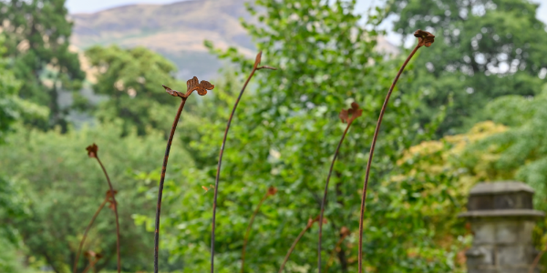
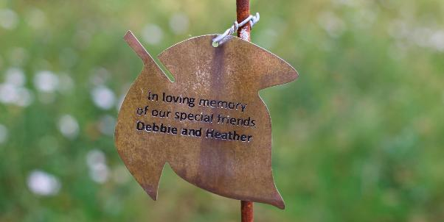

Memorial Option 3: Half Caithness Paving Stone (Stone path within the Garden of Time)
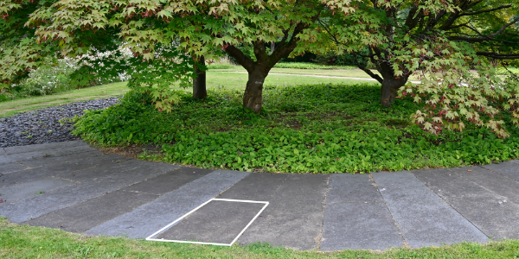

Memorial Option 4: Full Caithness Paving Stone (Stone path within the Garden of Time)
