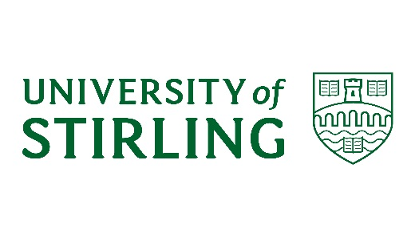
University of Stirling
Complaint Handling 2020-21
Introduction
- The University operates its complaints handling in line with the Scottish Higher Education Model Complaints Handling Procedure published by the Scottish Public Services Ombudsman (SPSO).
- This report provides a summary of complaints handling during 2020-21.

Overview of our Complaints Handling Procedure
- The University’s Complaints Handling Procedure involves up to two stages.
Stage One – Frontline resolution
Seeks to resolve straightforward complaints swiftly and effectively at the source of the concern or issue.
Stage Two – Investigation
Appropriate where a complaint is dissatisfied with the outcome of frontline resolution, or where frontline resolution is not possible or appropriate due to the complexity or seriousness of the case.
These two stages represent the full scope of the University’s procedure. Where a complainant remains dissatisfied at the conclusion of the University’s complaints process, a request can be made to the SPSO for an independent review of the complaint. The SPSO is the final stage for complaints about universities in Scotland.
Number of complaints received
- During the 2020-21 academic year the University had a total of 119 Stage One, frontline complaints, and a further 22 Stage Two complaints. There were a further 8 complaints which were referred to alternative University procedures (such as Academic Appeals), and 5 complaints which had been withdrawn.
- The total number of individual complaints handled was therefore 154.
- The difference in the volume of Stage One and Stage Two complaints indicates that the majority are resolved through frontline resolution (Stage One), in keeping with the University’s aims for early and satisfactory resolution.

When were complaints received?

Complainant demographics
- Of the 153 complaints received in 2020/21:
- 72 complaints were received from current students of the University
- 10 complaints were received from applicants to the University; and
- 72 complaints were received from members of the public.

Student complainants
- Of the 72 complaints received from students at the University in 2020/21:
- 52 complaints were received from undergraduates.
- 14 complaints were received from postgraduate taught students.
- 3 complaints were received from postgraduate research students; and
- 3 complaint was received from an INTO UoS student.

- Of the 72 complaints received from students at the University in 2020/21:

- 17 were received from students in Faculty of Arts and Humanities
- 10 were received from students in Faculty of Health Sciences and Sport
- 20 were received from students in Faculty of Natural Sciences
- 10 were received from students in Faculty of Social Sciences
- 10 were received from students in Stirling Management School; and
- 3 were received from students in INTO UoS.
- 2 complaints were received from groups of students.

- During the 2020-21 academic year the University had a total of 48 Stage One, frontline complaints from students, and a further 13 Stage Two complaints from students. There were a further 7 complaints which were referred to alternative University procedures (such as Academic Appeals), and 4 complaints which had been withdrawn.

- Complaints were received from students in the following months:

Categories of complaints received

*These categories were added in 2019/20 session to allow for improved analysis of information in light of COVID-19 pandemic.

Categories of complaints received from students

Complaint Response
- The objective set out in the model complaints handling procedure is to resolve Stage One, frontline complaints within five working days, and Stage Two complaints within 20 working days.
- However there are circumstances when it is not possible to resolve more complex complaints within this timescale. The University’s consistent objective is to consider and respond to complaints thoroughly and effectively.
- In 2020-21, 67 Stage One complaints were responded to within the first five working days, the responses for 33 complaints took more than working 20 days. The average time to respond to Stage One complaints was 9 working days.
- In respect of Stage Two complaints, the shortest response time was 15 working days and the average response time was 54 working days.

Outcomes
- In terms of outcomes of Stage One complaints, 18 were upheld, 5 were partially upheld, 42 were not upheld, and 51 were resolved.
- At Stage Two, 1 complaint was upheld, 1 was partially upheld, there were 9 not upheld, and 10 complaints are ongoing investigations at the time of writing this report.
Outcomes from student complaints
- In terms of the outcomes of the 48 Stage One frontline complaints received from students, 9 were upheld, 3 were partially upheld, 24 were not upheld, and 10 were resolved. 2 complaints were withdrawn.

- In terms of the outcomes of the outcome of the 13 Stage Two complaints received from students, 5 were not upheld, 1 was withdrawn, and 7 are being investigated at the time of writing this report.
Learning from complaints
- As part of the complaints process, the University teams are routinely requested to reflect on the outcome of the individual complaints and consider any lessons that can be learnt.

- Where Stage Two investigations identify areas of practice that could be improved or enhanced, recommendations are made within the complaint response, and progressed by the relevant faculty or directorate.

- On an ongoing basis, complaints are reviewed in order to determine any trends. Where a recurring theme is identified, this is highlighted and discussed with the appropriate area, or within a University forum.

