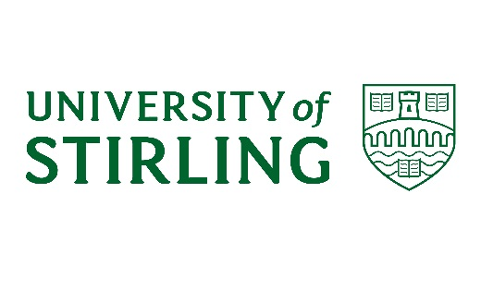
University of Stirling
Complaint Handling 2018-19
Introduction
- The University operates its complaints handling in line with the Scottish Higher Education Model Complaints Handling Procedure published by the Scottish Public Services Ombudsman (SPSO).
- This report provides a summary of complaints handling during 2018-19 academic session (1 August 2018 to 31 July 2019).

Overview of our Complaints Handling Procedure
- The University’s Complaints Handling Procedure involves up to two stages.
Stage One – Frontline resolution
Seeks to resolve straightforward complaints swiftly and effectively at the source of the concern or issue.
Stage Two – Investigation
Appropriate where a complaint is dissatisfied with the outcome of frontline resolution, or where frontline resolution is not possible or appropriate due to the complexity or seriousness of the case.
These two stages represent the full scope of the University’s procedure. Where a complainant remains dissatisfied at the conclusion of the University’s complaints process, a request can be made to the SPSO for an independent review of the complaint. The SPSO is the final stage for complaints about universities in Scotland.

Number of complaints received
- During the 2018-19 academic year the University had a total of 64 Stage One, frontline complaints, and a further 17 Stage Two complaints. There were a further 5 complaints which were withdrawn.
- The total number of individual complaints handled was therefore 81.
- The difference in the volume of Stage One and Stage Two complaints indicates that the majority are resolved through frontline resolution (Stage One), in keeping with the University’s aims for early and satisfactory resolution.

Categories of complaints received

- As demonstrated above, the University experienced a 28% decrease in total complaints handled from 2017-18 to 2018-19 academic sessions.

Complaint Response
- The objective set out in the model complaints handling procedure is to resolve Stage One, frontline complaints within five working days, and Stage Two complaints within 20 working days.
- However, there are circumstances when it is not possible to resolve more complex complaints within this timescale. The University’s consistent objective is to consider and respond to complaints thoroughly and effectively.
- In 2018-19, 29 Stage One complaints were responded to within the first five days, the responses for 13 complaints took more than 20 days. The average time to respond to Stage One complaints was 12 days.
- In respect of Stage Two complaints, the shortest response time was 26 days and the average response time was 55 working days.

Outcomes
- In terms of outcomes of Stage One complaints, 24 were Upheld, 14 were partially Upheld and 26 were Not Upheld.
- At Stage Two there were 10 Partially Upheld and 7 Not Upheld.

Learning from complaints
- As part of the complaints process, the University teams are routinely requested to reflect on the outcome of the individual complaints and consider any lessons that can be learnt.

- Where Stage Two investigations identify areas of practice that could be improved or enhanced, recommendations are made within the complaint response, and progressed by the relevant faculty or directorate.

- On an ongoing basis, complaints are reviewed in order to determine any trends. Where a recurring theme is identified, this is highlighted and discussed with the appropriate area, or within a University forum

