Template Consent form for Photography/Filming
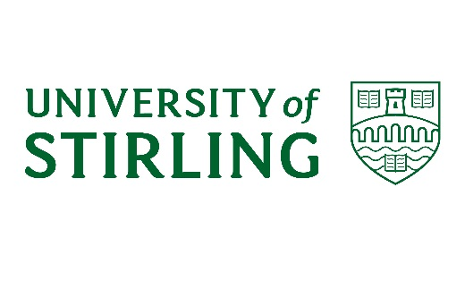
Consent form for photography/filming

I consent to the University of Stirling using photographs and/or video recordings including images of me both internally and externally to promote the University. These images could be used in print and digital media formats including print publications, websites, e-marketing, posters banners, advertising, film, social media, teaching and research purposes.

I understand that images on websites can be viewed throughout the world and not just in the United Kingdom and that some overseas countries may not provide the same level of protection to the rights of individuals as EU/UK legislation provides.

I understand that some images or recordings may be kept permanently once they are published and be kept as an archive of University life.

I have read and understand the conditions and consent to my images being used as described.

Print Name
Signature
Date

The University of Stirling is committed to processing information in accordance with the General Data Protection Regulation (GDPR). The personal data collected on this form will be held securely and will only be used for administrative purposes.

Your rights
You have the right to request to see a copy of the information we hold about you and to request corrections or deletions of the information that is no longer required. You can ask the University to stop using your images at any time, in which case it will not be used in future publications but may continue to appear in publications already in circulation.

You have the right to lodge a complaint against the University regarding data protection issues with the Information Commissioner’s Office (https://ico.org.uk/concerns/).

Contact details
If you have any questions relating to this consent form or the way we are planning to use your information please contact:
[Insert your contact details here: Name, department, address, email, telephone etc.]

If you have any questions relating to data protection please contact the University’s Data Protection Officer, Joanna Morrow, tel: 01786 466940, email data.protection@stir.ac.uk

