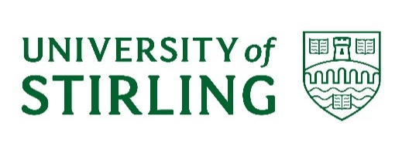
UNIVERSITY COURT

A meeting of the University Court will be held at 3.00 pm on Monday 23 October 2023 in the Stirling Court Hotel.

Members unable to attend the Court meeting, and who have not already tendered their apologies, are asked to email: sacsadmin@stir.ac.uk no later than Thursday 19 October 2023.

Eileen Schofield
University Secretary

AGENDA

1. DECLARATIONS OF INTEREST
To note any declarations of interest from Court members, as appropriate

2. MINUTES UC(22/23) Minutes 4
To approve the minutes of the meeting of University Court held on 12 June 2023

3. MATTERS ARISING NOT OTHERWISE ON THE AGENDA
To receive an update on any matters arising from previous minutes

4. REMIT, COMPOSITION AND MEMBERSHIP UC(23/24)1
To note the remit, composition and membership of Court for 2023/24

5. DEVELOPMENTS IN THE EXTERNAL ENVIRONMENT
To consider an update on recent developments in the external environment UC(23/24)2

INSTITUTIONAL PLANNING AND BUDGETING
6. THE STRATEGIC PLAN UC(23/24)3
To approve the Strategic Plan 2023-2030

7. PLANNING AND BUDGETING
i) QUARTER FOUR REPORTING UC(23/24)4
To receive the Q4 performance update and consider the Capital and Major Infrastructure update

ii) ANNUAL REVIEW OF PERFORMANCE UC(23/24)5
To consider a report on the University’s performance in 2022/23
iii) STUDENT NUMBERS UC(23/24)6 To consider the update on student numbers

COLLABORATION
8. CITY DEAL UC(23/24)7
To receive the report from the University’s City Region and Growth Deal Programme Board

GOVERNANCE
9. ANNUAL REPORT ON INSTITUTION-LED REVIEW UC(23/24)8
To approve the Annual Report to the Scottish Funding Council on Institution-Led Review in 2022/23

10. SFC OUTCOME AGREEMENT 2023/24 UC(23/24)9
To approve the 2023/24 Outcome Agreement documentation for submission to the Scottish Funding Council

POLICY
11. TREASURY MANAGEMENT POLICY UC(23/24)10
To approve the revised Treasury Management Policy

ACTIVITY UPDATES
12. STUDENTS’ UNION UPDATE UC(23/24)11
To receive an update on activity from the Students’ Union

13. STAFF AND EMPLOYMENT UPDATE UC(23/24)12
To receive an update on matters relating to staff and employment

COMMITTEE REPORTS
14. ACADEMIC COUNCIL UC(23/24)13
To consider the report from the meeting of 13 September 2023

15. REMUNERATION COMMITTEE UC(23/24)14
To consider the report from the meeting of 12 June 2023

16. GOVERNANCE AND NOMINATIONS COMMITTEE UC(23/24)15
To consider the report on committee appointments approved by GNC.

RISKS
17. RISKS ARISING Oral
To consider risks associated with any items discussed in the context of the agreed risk appetite statement

OTHER ITEMS
18. ANY OTHER COMPETENT BUSINESS

19. NEXT MEETING
To note the next full meeting of Court is scheduled for Monday 11 December 2023.

Policy & Planning
October 2023

