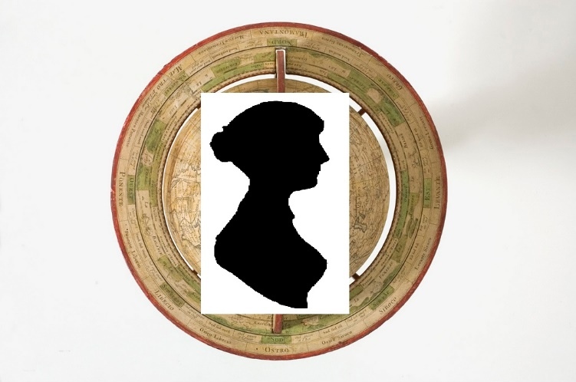

CALL FOR PAPERS

The Global Jane Austen: Celebrating and Commemorating 250 years of Jane Austen

University of Southampton, July 10-12, 2025

Austen scholars and enthusiasts are invited to the University of Southampton, Hampshire, for a conference commemorating Austen’s birth in the year 1775.

In 1976, Juliet McMaster introduced an edited collection of essays resulting from a bicentenary birthday celebration for Austen in the following terms:
To celebrate the two-hundredth anniversary of Jane Austen’s birth in October, in Western Canada, is no doubt to be guilty of a comic incongruity. But as though to compensate for the misdemeanor, the papers delivered at the conference have a common and exact focus on period and locale.
50 years after the bicentenary conference at the University of Alberta in Edmonton, the scholarly landscape of Austen studies has changed. Where many monographs and edited collections of essays still maintain an ‘exact focus on period and locale’, research informed by book history, the material, archival and linguistic turns in literary criticism, postcolonial studies and adaptation theory (among others) has flourished in the intervening decades. The ever-expanding corpus of adaptations, sequels and prequels has proven fruitful territory for a consideration of Austen’s reception, in its broadest sense. Austen’s transformations into other languages and into other cultures make her a Global author.

We invite the international community to the port city that was Jane Austen’s home from 1806-1809 for a consideration of the Global Jane Austen. We encourage the broadest possible interpretation of the conference theme, and welcome papers on all aspects of Austen’s writing and life, her posthumous reception, her influences, and her writing alongside that of her contemporaries. We particularly welcome papers on adaptations, translations and creative responses to Austen’s work (written and/or performed in all languages), material and textual transmission of her works, and her reception and reputation in countries outside the Anglophone world. Discussion of the Global within her works (and those of her contemporaries) is equally acceptable.
Submission

Please submit abstracts for individual papers of 250 words, or proposals for 3-person panels of 1000 words, to the conference organisers, Gillian Dow and Katie Halsey. Please submit as Word or PDF documents by email to both G.Dow@soton.ac.uk and katherine.halsey@stir.ac.uk by 1 October 2024.

Confirmed Speakers Include:
Susan Allen Ford; Serena Baiesi, Janine Barchas; Jennie Batchelor; Annika Bautz; Isabelle Bour; Joe Bray; Linda Bree; Inger Brody; Valérie Cossy; Richard Cronin; Carlotta Farese; Susannah Fullerton; Sayre Greenfield; Isobel Grundy; Christine Kenyon Jones; Freya Johnston; Michael Kramp; Devoney Looser; Deidre Lynch; Anthony Mandal; Juliet McMaster; Marie Nedregotten Sørbø; Peter Sabor; Diego Saglia; Rebecca Smith; Jane Stabler; Kathryn Sutherland; Bharat Tandon; Janet Todd; Anne Toner; Linda Troost; Juliette Wells.

Image: A 1765 de l'Isle globe, showing top view. Collection of the Minnesota Historical Society, with silhouette of 'L'Aimable Jane' (NPG 3181) superimposed. Both images reproduced under the Creative Commons license CC BY-SA 4.0.

