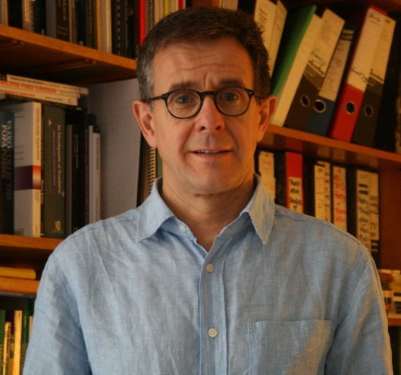
Profile
Dr. Francis Jones is a Professor of Translation Studies at the School of Modern Languages, Newcastle University. He currently teaches translation, interpreting studies, literary translation, and research methods at Newcastle University. His main research interest lies in poetry translation which specifically focuses on translation from Dutch and Bosnian-Croatian-Serbian. He is also interested in identity, ideology, and the social/ethical role of the poetry translator. Dr. Jones is now working on an AHRC-funded project looking at how poets translate each other’s work with the help of bilingual translator intermediaries.

Abstract
Rhyme and Reason
Poetry translating and the challenge of form
Francis Jones
Professor of Translation Studies, School of Modern Languages, Newcastle University
francis.jones@ncl.ac.uk
You know the scene: you're talking to someone at a party and they ask, “So what do you do?” When I answer “I'm an academic, and also a poetry translator”, the reply usually goes: “Translating poetry– that must be difficult!”. So why is poetry, of all genres, seen as uniquely challenging to translate? To my mind, virtually everyone knows that poems have not just literary content, but typically also formal devices – rhyme, rhythm, and other ways of playing with words. And that these devices tend to be language-specific. (Translating publicity or interpreting for political leaders is no less challenging, but this is less well known to outsiders, I guess.)

The person at the party is right, of course. The default modern-day norm in literary translation is: try to stay loyal to the source while creating a target text that works as target-language literature. But if the source uses rhyme and rhythm, it is indeed long, hard work to loyally recreate this. And the translator often has to play fast and loose with source semantics to do so. Hence some poetry translators find the task too tricky, or see shifting away from source content as unethical. So they abandon formal devices, and translate into free verse instead.

In this talk, I explore these challenges, and the pros and cons of recreating versus abandoning source-poem form. I then use examples from my own research, and my own practice, to show how translators into English and related languages actually tackle these challenges. Among the studies I refer to is a project where Dutch and UK poets translate each others’ work, helped by bilingual intermediaries. This allows us to see whether those who call themselves “poets” have different approaches than those who, like me, who call themselves “translators”.

I will also be interested in any insights you may have, as audience, into translating across other language pairs.

