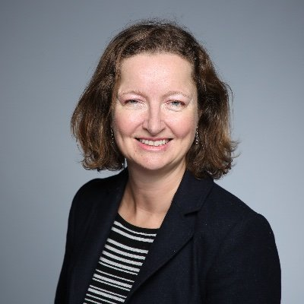

Multilingual life writing by French and Francophone women: Translingual selves
Natalie Edwards University of Bristol

This talk, based upon my book Multilingual Life Writing, examines the ways in which multilingual women authors incorporate several languages into their life writing. The book compares the work of six contemporary authors who write predominantly in French. It analyses the narrative strategies they develop to incorporate more than one language into their life writing: French and English, French and Creole, or French and German, for example. The book demonstrates how women writers transform languages to invent new linguistic formations and how they create new formulations of subjectivity within their self-narrative. It intervenes in current debates over global literature, national literatures and translingual and transnational writing, which constitute major areas of research in literary and cultural studies. It also contributes to debates in linguistics through its theoretical framework of translanguaging. It argues that multilingual authors create new paradigms for life writing and that they question our understanding of categories such as "French literature."

Bio
Natalie Edwards is Head of the School of Modern Languages and Professor of Literature in French at the University of Bristol. She specialises in Francophone writing, transnational writing, migrant writing and multilingual writing. She has published three monographs, the most recent of which is Multilingual Life Writing by French and Francophone Women (Routledge, 2020).

