**Stirling Law School’s Bulletin 3/2022**

This bimonthly bulletin is for sharing Stirling Law School’s achievements in research, teaching, and engagement. In these difficult times, it’s crucial to celebrate, strengthen our sense of community, and create opportunities for cross-Faculty and cross-University collaborations. We hope you’ll enjoy this wee snippet of Stirling Law School’s recent successes.

Table of Contents

Highlight of this issue 1

Impact and engagement 2

Income generation 2

Publications 3

*Books* 3

*Journal articles* 4

*Chapters* 4

*Reports* 5

PGR success 6

Research environment 7

Employability news and teaching Excellence 8

Esteem, network, and citizenship 9

Dissemination and media presence 10

Internationalisation 11

Events organised 12

Upcoming events 13

Upwards and onwards 13

Get in touch 13

# **Highlight of this issue**

Dr Dave McArdle contributed to a successful grant application to the **Erasmus+** funding scheme on **Sport and Sustainable Development Goals** (SDG). The relationship between sport and the environment has long been established, and building on the impetus from the 2021 COP climate summit in Glasgow, nearly 300 international and national sport organisations have signed up to the [UN Framework for Climate Action in Sport](https://unfccc.int/climate-action/sectoral-%20engagement/sports-for-climate-action). The framework requires organisations to pledge commitment to climate targets, to plan, proceed with action and report on their actions and the project will significantly enhance the capacity of both HE institutions and sport organisations by advising on structure and delivery of sustainable sport management curricula. His role is to advise on the law-related content of those curricula.

# **Impact and engagement**

From 19-23 September 2022, Professor Paul Beaumont FRSE will continue to **represent the EU** in the Working Group on Jurisdiction at the **Hague Conference on Private International Law** (HCCH). The HCCH is the global organisation charged by its Members (91 States and the EU) to work for the “progressive unification of private international law rules”. The Working Group is currently focusing on trying to agree a new Convention regulating cases where the parties are in dispute in civil or commercial matters in the courts of more than one State.

As part of the [EU Digital Education Action Plan (2021-2027)](https://education.ec.europa.eu/focus-topics/digital-education/action-plan), the **European Commission** has commissioned a study about “**Policy options for digital education content in the European Union**”. The aim of the study is to provide a solid basis of knowledge and analysis about digital education content in the EU and present policy options to support the development of quality digital education content. The study will contribute to fostering the development of a high-performing digital education ecosystem. To this end, the study will establish a **Stakeholder Consultation Group** (SCG). Our Associate Professor Guido Noto La Diega has been invited to join the SCG in light of their research in the field of EdTech and the law, and their previous work in the European Commission’s [Expert Group on AI and Data in Education and Training](https://ec.europa.eu/transparency/expert-groups-register/screen/expert-groups/consult?do=groupDetail.groupDetail&groupID=3774). The SCG will function as a managed community of invited practitioners, educationalists, sector representatives, policy makers, social partners, education content suppliers and publishers. Activities will aim to encourage deeper cooperation, collaborative learning and sharing of good practice. It will also be an opportunity for stakeholders to share their views on key challenges and enablers when it comes to leveraging digital education content for high-quality learning, and to co-create solutions.

In May 2022, the **European Commission** published its final report [*Behavioural study on unfair commercial practices in the digital environment: Dark patterns and manipulative personalisation*](https://op.europa.eu/en/publication-detail/-/publication/606365bc-d58b-11ec-a95f-01aa75ed71a1/language-en/format-PDF/source-257599418). Therein, the Commission cited Guido Noto La Diega’s [*Data as Digital Assets. The Case of Targeted Advertising: Towards a Holistic Approach?*](https://www.researchgate.net/publication/328706352_Data_as_Digital_Assets_The_Case_of_Targeted_Advertising_Towards_a_Holistic_Approach) to argue for a regulatory approach that **considers targeted advertising holistically** and brings together consumer protection, competition law, and intellectual property. A reference was made also to Guido’s proposal for more reasonable and enforced opt-out mechanisms, and to the gamification of mandated disclosures.

# **Income generation**

Associate Professor Guido Noto La Diega is part of a team that has been awarded a **Horizon Europe** grant for the project “*MEGASKILLS.* ***MEthodology of Psycho-pedagogical, Big Data and Commercial Video GAmes procedures for the European SKILLS Agenda Implementation***” (2022–25), led by Dr Iker Martínez de Soria Sánchez (Tecnalia) and Dr Flavio Escribano (GeCon.es Foundation). Guido will act as Data & Privacy Advisor from (Stirling allocation: €34,126.50)

Guido has **closed the BILETA-funded project** [‘Zooming in on Education: An Empirical Study on Digital Platforms and Copyright in the United Kingdom, Italy, and the Netherlands](https://www.stir.ac.uk/research/hub/contract/1660502)’ with a final dissemination event at *Connecting Legal Education* (CLE#39), Lancaster University (online), Tuesday 24th May 2022. Guido led a team of six international scholars that explored the phenomenon of the **‘platformisation’ of education** through quantitative and doctrinal methods. The outputs of this project are a short report for academics and policy makers, and two articles that have been accepted for publication in leading international peer-reviewed journals.

A positive sign of collaboration between the divisions of the Faculty of Arts and Humanities, Guido has joined the advisory board of the **Branded Content Governance Project**, jointly funded by the Economic and Social Research Council (ESRC) and the Arts and Humanities Research Council (AHRC). The project is led by Professor Jonathan Hardy (University of the Arts London) and, at Stirling, co-investigated by Professor Iain MacRury. This international research project examines the regulation, policies, practices, and communications surrounding brand-funded content, including sponsored content, native advertising, and influencer marketing. The team will produce a detailed, comparative mapping of the emerging rules and practices for content funded or produced by brands across the UK, all EU countries, the US, Canada and Australia.

# **Publications**

## *Books*

In September, W. Green has published the [book](https://www.sweetandmaxwell.co.uk/Product/Family-and-Social-Welfare-Law/Child-and-Family-Law-Volume-II-Intimate-Adult-Relationships/Hardback/30798146) ***Child and Family Law: Vol II: Intimate Adult Relationships*** by our own Professor Emerita Elaine E. Sutherland.

This new edition addresses the recent wealth of changes in child and family law, now warranting two volumes to encompass the depth of its authoritative treatment.

Dr Geoffrey Wood saw the publication of his sixth book From **Fossil Fuels to Low carbon Energy Transition: New Regulatory Trends in Latin America** (co-edited with Dr Juan Felipe Neira Castro, a senior consultant at the National Energy Regulator of Colombia). Published by Palgrave Macmillan as part of their energy, climate and the environment series, the book focuses on 5 key themes - hydrocarbons, electricity, mining, social license to operate and arbitration/dispute resolution - via in-depth country and regional case studies, to capture the contrasting and at times conflicting trends in energy governance in Latin America as the region wrestles with a dependence on fossil fuels whilst shifting towards a low carbon future. It has been a fantastic experience to work with experts from all across Latin America, a region primed for rapid renewable energy growth! A huge thanks to all the chapter authors who contributed their time and expertise!

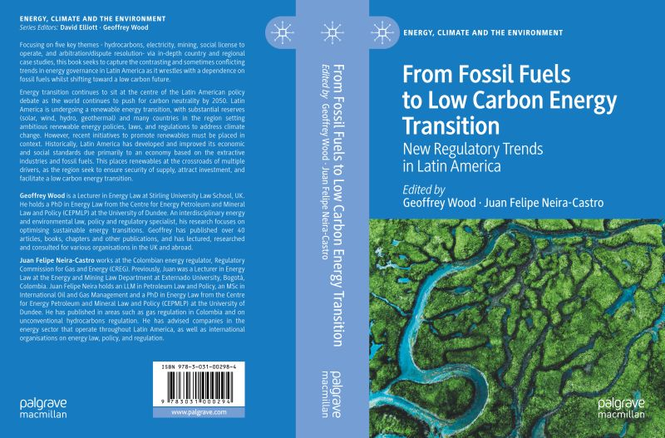

## *Journal articles*

D. Carolei, ‘**An International Ombudsman to make non-governmental organizations more accountable? Too good to be true …**’ is now published online by the Leiden Journal of International Law - [here.](https://eur03.safelinks.protection.outlook.com/?url=https%3A%2F%2Fwww.cambridge.org%2Fcore%2Fjournals%2Fleiden-journal-of-international-law%2Farticle%2Fabs%2Fan-international-ombudsman-to-make-nongovernmental-organizations-more-accountable-too-good-to-be-true%2FE86232F60C8F6327F9CF7B0DD660335D&data=05%7C01%7Cguido.noto.la.diega%40stir.ac.uk%7C967907b6643449a2b89408da97d2a60a%7C4e8d09f7cc794ccb9149a4238dd17422%7C0%7C0%7C637989228218587180%7CUnknown%7CTWFpbGZsb3d8eyJWIjoiMC4wLjAwMDAiLCJQIjoiV2luMzIiLCJBTiI6Ik1haWwiLCJXVCI6Mn0%3D%7C3000%7C%7C%7C&sdata=O%2F%2BcKdua%2BkhJa5N5CPtQGkvnd5niXabg58%2Bfac6aoeI%3D&reserved=0)

In 2018, the Dutch Government proposed to establish an independent international ombudsman, known as the International Ombuds for Humanitarian and Development Aid (IOHDA), to hold non-governmental organizations (NGOs) accountable for their safeguarding and accountability failures, notably the Oxfam GB sexual abuse scandal in Haiti (March 2018) and in the Democratic Republic of Congo (April 2021). While establishing an international ombudsman would fill a regulatory and accountability gap in global governance, there are many legal and logistic challenges, some of which have been identified by the IOHDA proposal itself, that undermine the creation of this brand new body. Besides the legal and logistic challenges outlined in the proposal, this article argues that the IOHDA is unlikely to succeed because of three additional challenges. First, the IOHDA’s scope is too broad and misinterprets the ombudsman’s jurisdiction and traditional role. Second, the IOHDA neglects that existing ombudsman schemes present limitations in enacting accountability and does not learn any lessons from them. Third, the IOHDA lacks support from NGOs, a driving force, and the principal standard-setters for an international accountability mechanism, like the proposed ombudsman. This article provides a series of recommendations to mitigate these three challenges whilst identifying alternative routes to enact NGO accountability.

## *Chapters*

Professor Paul Beaumont and Dr Jayne Holliday have published an up-to-date account of the **private international law of succession in Scotland** which, inter alia, analyses the historical development of domicile as the connecting factor for succession in Scotland (coming from a civil law tradition and being exported from Scotland to England and beyond). See Paul Beaumont and Jayne Holliday, “Private International Law of Succession, Scotland” in Stefania Bariatti, Ilaria Viarengo and Francesca Villata (eds) *EU Cross-Border Succession Law* (Edward Elgar, 2022) 450-469.

Guido Noto La Diega, Giulia Priora, Bernd Justin Jütte, and Léo Pascault), ‘**Capturing the Uncapturable: The Relationship between Universities and Copyright through the Lens of the Audio-Visual Lecture Capture Policies**’ in Cristiana Sappa and Enrico Bonadio (eds), The Subjects of Literary and Artistic Copyright (Edward Elgar 2022) 207-233. The book can be pre-ordered [here](https://www.e-elgar.com/shop/gbp/the-subjects-of-literary-and-artistic-copyright-9781800881754.html), the preprint is available [here](https://papers.ssrn.com/sol3/papers.cfm?abstract_id=4008227).

The COVID-19 pandemic has consolidated a double move. On the one hand, universities are becoming increasingly aware of the strategic value of copyright. On the other hand, the necessity to embrace distance education is making universities realise that there is a wealth of issues that go beyond ownership of research outputs and reprography rights. Understanding the role of universities as copyright subjects today requires understanding the rise of the ‘platformisation’ of learning, which this chapter does by analysing the audio-visual lecture capture policies of the largest universities in the United Kingdom, Ireland, Italy and France. The rules on lecture capture represent a meaningful entry point to investigate strengths and weaknesses of the universities’ approach to the creation and use of protected content online. Through this lens, it is possible to reflect on both the underlying exacerbated power imbalance between universities and teachers, and the diverging approach towards copyright law across the European higher education landscape. First, the chapter considers whether the selected universities had a specific policy on lecture capture, and, if so, what it covered, and where the default rule sat in the continuum between opt-out and opt-in. Then, it investigates issues of ownership of the lecture recordings, including the incorporated slides and other materials as well as the performance rights. Ownership rules significantly affect who can exploit the recordings and under which conditions, thus raising delicate and timely questions on the management and commercialisation of recorded lectures, the protection of moral rights and the retention of economic ones. Despite stark differences between the selected countries’ approach, the clear trend towards an increased expectation that teachers have to record their lectures epitomises the digital dispossession that is inherent to the platformisation of education. Nonetheless, the oft-forgotten rights in performances can still play a role in pursuing a fairer balance between the competing interests at play.

## *Reports*

In July 2022, the second volume of the Annual Report of the Global Digital Encounters was published: L. Manderieux, M. Desantes, J.Fernandez-Lasquetty, A. Arribas (eds.), [*Re-Imagining IP in an ever-changing world, Global Digital Encounters*](https://thinkfide.com/re-imagining-ip-in-an-ever-changing-world-global-digital-encounters-vol-2/?utm_medium=email&utm_campaign=GDE+Vol+2.), FIDE/TIPSA, 2022. The Fide Foundation, a legal-economic think-tank operating out of Madrid, and TIPSA (Transatlantic Intellectual Property Academy) continue to join forces to organise, since the first weeks of the Covid pandemic back in 2020, a longstanding Program of Global Digital Encounters, scheduled periodically around the area of Intellectual Property, with the goal of “Re-imagining IP in an ever-changing world". All online encounters were open to anyone and followed by the dissemination of videos and reports. The speakers – including our Guido Noto La Diega – were selected among the most influential IP scholars and professionals all over the world. Each encounter was attended by up to 1000 participants from 60-70 countries of all continents. Guido’s *Encounter* dealt with ‘***Expanding Business thanks to the Data Economy****: IP as a Tool*” (watch the video [here](https://thinkfide.com/global-digital-encounters/gde-14-expanding-business-thanks-to-data-economy-ip-as-a-tool/)).

# **PGR success**

**Cheng Chen**, co-supervised by Professor Hong-Lin Yu and Dr Damian Etone **passed her viva** on 1 September 2022 and will graduate in November 2022. The exam committee commented positively on the thoroughness of the research and its originality. The topic is “**The Challenges of Applying the Principle of Proportionality in Striking a Balance in the Investor-State Relationship – from the International and Chinese Perspectives**".

One significant concern in the current international investment is the imbalance between foreign investors' interests and the host state's right to regulate in the public interest. Broad investment protections are enjoyed by foreign investors, such as the protection of legitimate expectations included in fair and equitable treatment, whereas the host state's regulatory power for the public interest is somewhat restricted. How to strike a balance in such an imbalanced investor-state relationship is being considered by states, including China, to deliver their sustainable foreign investment.

Proportionality, which first originated in Germany, has been noted by scholars as an appropriate tool to strike a balance between private rights and the state's regulatory power by three consecutive assessments of suitability, necessity, and proportionality stricto sensu, respectively. However, how to bring this method into the settlement of investor-state disputes and how to apply it to balance conflicting values between foreign investors and the host state raise debates. Due to its failure to fulfil the requirements of Article 38 (1) of the Statute of the International Court of Justice, the application of proportionality depends on the interpretation of each case. Proportionality can be applied if it is expressed in the case-related treaty or if it is included in the host state's domestic law, which is the applicable legal instrument of the case. A systemic interpretative method then is needed to apply proportionality in investor-state arbitration.

This research tests the possibility and practicability of applying proportionality in striking a balance between the investor-state relationship from the international and Chinese perspectives to ascertain an appropriate method to balance the investor-state relationship in international investment, particularly in Chinese international investment. Due to its dual role in international investment, a balanced investor-state relationship is in China's interest. The approach it adopts may also benefit the capital-importer and exporter.

In the last issue, we forgot to say that one of our PhD students, **Mohammad Abu Hazeem**, co-supervised by Professor Hong-Lin Yu and Dr Mo Egan, passed the viva without correction on 18 May 2022. His PhD thesis is titled "**Challenges Undermining the Use of Mediation in the Jordanian Civil Justice System: Lessons Learnt from England**". The examination Committee is comprised of Professor Bryan Clark (Newcastle Law School), Dr Pontian Okoli (Stirling Law School) and Dr Emma MacLeod (Independent Chair, HPH, Stirling). Both examiners spoke very highly of the quality of work produced and recommends the award of a **PhD without correction**.

Dr Abu Hazeem’s research explores the challenges that undermine the use of mediation in Jordan, and the lessons that can be learnt from the English civil justice system. The main goals of the research are to fill in the gaps in the Jordanian literature regarding the use of mediation and, significantly, for Jordan to learn from English practices that would contribute to the uptake in the use of mediation. The study employs a qualitative approach in conducting semi-structured interviews with seventeen Jordanian judges with experience in court-based mediation, and a quantitative approach in disseminating a questionnaire to 99 lawyers to gain insight into their perspectives and experiences in engaging in the practice of court-based mediation. The findings of the empirical study identified several barriers to the use of mediation in Jordan that informed the comparative study with England, mainly the lack of a court duty or power to encourage the use of mediation, lack of statutory and professional duty upon lawyers to encourage their clients to attempt mediation before litigation, and the lack of mediation education, training and awareness among stakeholders (judges, lawyers and public). Furthermore, the study explores the concept of access to justice and mandatory mediation. The study concludes that these obstacles can, potentially, be overcome. This would involve a system based on the English experience of imposing a duty on the court to encourage the use of mediation, and vesting the court with the power to impose costs sanctions on parties for refusing to attempt mediation unreasonably. Lawyers and the parties involved would help the court to further the overriding objective of the CPR by engaging in mediation, and by increasing mediation education, training and awareness among stakeholders. Accordingly, the study presents a theoretical and practical framework to the further development of court-based mediation in Jordan.

Congratulations, Dr Abu Hazeem and Dr Chen!

# **Research environment**

We are delighted to report that the Law School has secured a most competitive **SGSAH scholarship** that will fund the project ‘**The backdoor propertisation of knowledge**: are Big Tech using copyright law and emerging technologies to privatise education?’ by our new PhD student Cheryl Warden. Cher will be supervised by Associate Professor Guido Noto La Diega, Dr Zoi Krokida, and Dr Terrie-Lynn Thompson (Faculty of Social Sciences, Department of Education). Thanks to Professor Paul Beaumont, Professor Hong-Lin Yu, and Dr Mo Egan for the support. Do [reach out to Cher](mailto:Cheryl%20Warden%20%3cc.e.warden1@stir.ac.uk%3e) if you are interested in EdTech, copyright, and/or education.

As part of the activities of the Stirling-based Scottish Law and Innovation Network (funded by the Royal Society of Edinburgh), and with the support of the Institute for Advanced Studies, Professor Iain Docherty, and Dr Mo Egan, the Law School has hosted **visiting researcher** Mona Winau (Goethe-University Frankfurt am Main-Karlsruhe Institute of Technology) who presented her work on [enforcement deficits in data protection](https://www.scotlin.org/post/en-lightening-talk-mona-winau-goethe-university-frankfurt-am-main) and the challenges of **comparative research in a post-Brexit world**. The seminars were delivered in a hybrid format, and they were a great opportunity for staff across the Faculty of Arts and Humanities to meet and have multidisciplinary conversations around data governance. They were also an opportunity to showcase the **stunning new Campus Central facilities**! Mona is now back in Edinburgh as she is being co-supervised in her visit by Professor Burkhard Schafer (Edinburgh Law School) and our usual suspect Guido Noto La Diega.

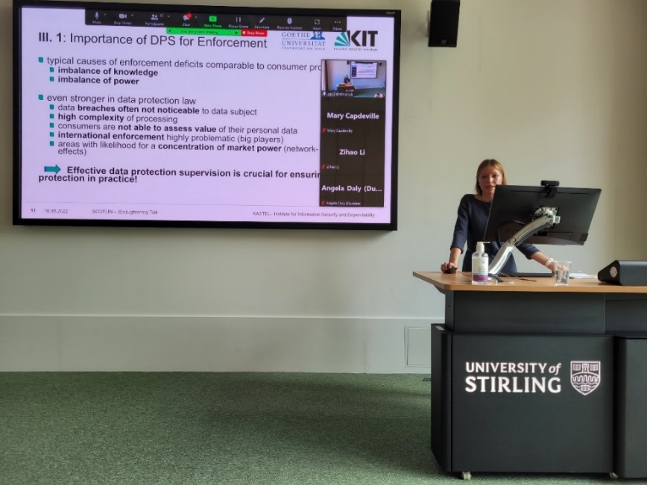

Nicolò Pozzato, a PhD student from the University of Padua, will be based at the University of Stirling from 1st October 2022 to 1st January 2023. He is carrying out doctoral research about **data governance and open innovation**. The University of Padua is Italy’s second oldest university, where Galileo taught, and Copernicus studied. He will be supervised by Guido Noto La Diega and Zoi Krokida. Colleagues working on open innovation, data governance, and related matters are encouraged to [reach out to our new **visiting PhD student**](mailto:nicolo.pozzato@stir.ac.uk).

# **Employability news and teaching Excellence**

Dr Jayne Holliday developed a **substantial induction programme** for new and returning law students at Stirling from 12-16 September 2022. It was particularly gratifying to see a huge turnout of first year LLB and BA Law students at the main induction events and their introductory in person lectures for the first semester subjects. The Law School continued to offer a staff-student walk (much appreciated by those who came), introduced new meetings with year tutors and began a new support group for law students who are carers.

**Internships** – 30 of our students on the MSc programme in Human Rights and Diplomacy are now undertaking internships with various national and international organisations. These organisations include The Scottish Funding Council, Central Scotland Regional Equality Council, Centre for World Indigenous Studies, Migration Policy Institute (Brussels), UN Women (Brussels and New York), UN Economic Social Commission for Asia and the Pacific (Bangkok), FAO (Rome), International Anti-Corruption Academy (Austria), UNICEF, East African Centre for Human Rights (Nairobi), Revive Campaign, 21 Wilberforce (Washington DC), Scottish Pen, Refugee Survival Trust, Forth Valley Welcome, and Wandering Educators. More details available [here](https://pdf.ac/VYxb3).

Associate Professor Annalisa Savaresi has been delivering **teaching internationally**:

* Interdisciplinary summer school ‘Awareenergy’ organised by the University of Trieste, <http://www.awarenergy.it> (June 2022)
* ‘Business and HRS’ summer school organised by the University of Milan <https://www.bhrsummerschool.com/> (June 2022)
* Summer school ‘ CAP 2023-2027 and Sustainable Agri-Food Systems’ organised by the Sant’Anna School of Advanced Studies, sponsored by the Jean Monnet Programme, <https://www.sustain.santannapisa.it/summerschool2022> (July 2022)
* Course “Human rights and the Environment’ organised by the Geneva Academy of International Humanitarian Law and Human Rights (September 2022)

# **Esteem, network, and citizenship**

Our new Lecturer in Scots Law Dr Leslie Dodd has elected to the Council of the [Stair Society](https://eur03.safelinks.protection.outlook.com/?url=http%3A%2F%2Fwww.stairsociety.org%2F&data=05%7C01%7Cguido.noto.la.diega%40stir.ac.uk%7Cfdb0e9298fc348a3ac2808da929b7ebd%7C4e8d09f7cc794ccb9149a4238dd17422%7C0%7C0%7C637983493785423242%7CUnknown%7CTWFpbGZsb3d8eyJWIjoiMC4wLjAwMDAiLCJQIjoiV2luMzIiLCJBTiI6Ik1haWwiLCJXVCI6Mn0%3D%7C3000%7C%7C%7C&sdata=JOS4%2BEvVBaHBuETtiiaW6o1%2BelW2yKSONo4y0upHu3E%3D&reserved=0) with effect from April 1st. The Stair Society is **Scotland’s leading legal history society**. It was founded in 1934 to encourage the study and advance the knowledge of the history of Scots Law by the publication of original documents and by the reprinting and editing of works of sufficient rarity or importance.

**Universal Periodic Review Academic Network** (UPRAN) - the UPR Academic Network (UPRAN) was launched in June 2022 by Dr Damian Etone (University of Stirling), Dr Amna Nazir & Dr Alice Storey (both at Birmingham City University). UPRAN brings together a global network of researchers and academics working on the UPR to share the nature of UPR research already undertaken, exchange ideas for collaboration, and consider new perspectives and under-research aspects of the UPR. It is an interdisciplinary network of scholars working on the UPR mechanism of the Un Human Rights Council. Follow us on twitter at @UPRAcademics

At the annual conference of the **Society of Legal Scholars** (SLS) at King’s College, London Professor Beaumont succeeded Professor Colin Reid, University of Dundee, as the **Convener for Scotland** on the Executive Committee of SLS. Dr Jayne Holliday continued to represent Stirling Law School on the Council of the SLS, and Associate Professor Noto La Diega continued to co-convene the Open Section of the Conference.

The previous issue mentioned the role of staff at Stirling Law School in supporting Ukrainian academics currently in the UK (**Science for Ukraine**). We are delighted to say that a PGR student mentored by Dr Dave McArdle has secured a six-month research post, generously funded by our colleagues at Bristol University Law School. Dave was able to help the candidate secure interviews with several MPs and MSPs to help strengthen their application. Meanwhile, Guido Noto La Diega has joined the cohort of mentors of the CARA (**Council for At-Risk Academics**), a British charity providing urgently-needed help to academics in immediate danger, those forced into exile, and many who choose to work on in their home countries despite serious risks. Guido is now supervising an Afghan researcher who has safely arrived in Edinburgh with his family.

Associate Professor Annalisa Savaresi has been appointed **Visiting Research Fellow**, University of Edinburgh, **Edinburgh Climate Change Institute** <https://edinburghcentre.org/> (September-December 2022)

Guido has joined the founding **Advisory Committee** of the **Law and Technology in UK Law Schools Network** led by Professor Roger Brownsword and Associate Professor Lorna Gillies. The network – the first of its kind – is being set up with a focus on Law and Technology in the UK Law School (broadly conceived) and the benefits and necessity for pragmatism and the potential for cross/interdisciplinary research and teaching. The network will organise a series of Workshops across the UK to bring together expertise which defines and leads the agenda in both research and teaching of Law and Technology in UK Law Schools, looking towards and responding to "The Law School 2061." Guido’s appointment – alongside world leaders such as Professor Lilian Edwards (Newcastle), Professor Andrew Murray (LSE) and Professor Karen Yeung (Birmingham) – is in recognition of “the work you have done and are doing to support both research and teaching of Law and Technology in UK Law Schools”.

Guido has also joined the **Advisory Board** of the University of Stirling’s [Enterprise Programme](https://www.stir.ac.uk/research/who-were-working-with/innovation-and-enterprise/" \o "https://www.stir.ac.uk/research/who-were-working-with/innovation-and-enterprise/), which  provides students, staff, and recent graduates with a diverse offering of activities, services, and funding opportunities to support innovative activities, develop and grow business ventures of all kinds, and build entrepreneurial skills for the future world of work.

Finally, Guido (*give us a break!)* co-founded **the International Future of Law Association (IFLA)**, that brings together legal scholars, professional practitioners and others from across the globe who share an interest in the future of law and legal practice. The members of IFLA are committed to research and teaching of law, innovation, and new technologies.

# **Dissemination and media presence**

In September, Dr Dave McArdle spoke at a workshop on the **ethical and policy issues arising in sport-related concussion**. This was a high-level meeting, funded by the International Olympic Committee on behalf of six international sports federations, to consider the ethical issues that have arisen from the six SRC consensus statements that have been produced by the global medical community over the past two decades (particularly the concerns over contributor selection, methodological biases, conflict of interest and other issues concerning who gets heard and who is silenced). The next consensus statement is due for publication in late 2022, and the workshop advised its authors on two broad issues. First, the need to review the processes of selection of authors and perspectives, fair reporting, authorship ethics and conflicts of interest; and, second, to emphasise the importance of the need for multidisciplinary input beyond the medical sciences. Dave provided a systematic review which explained how most of the potential legal responses which have been discussed by the scientific community – personal injury litigation, health and safety legislation or waiver clauses – dissuade volunteers while doing nothing for participant safety. All the systematic reviews will be published in the British Journal of Sport Medicine in late 2022. The BJSM will also publish a special issue of longer papers from the contributors in 2023.

Dr Benjamin Clubbs Coldron has taken over the coordination of **SCOTLIN’s (en)lightening talks**. In these open online (and sometimes hybrid) knowledge exchange events, pressing law & innovation issues are presented to non-experts in an accessible and engaging way. See past events [here](https://www.scotlin.org/enlighteningtalks).

Dr Domenico Carolei was member of the conference academic committee, and also presented two papers at the15th International Conference International Society for Third-Sector Research (ISTR), Concordia University (Montreal, Canada), 12-15 July 2020:

• ‘**The OECD norms on civil society**: protecting civil space while making CSOs more accountable’ co-presented with Dr Jaqualine Wood (Senior Civil Society Specialist, OECD Paris)

• ‘**NGO Accountability in the eyes of the Law**’

Associate Professor Annalisa Savaresi has presented at the side event “**Human Rights and Climate Change**” 51st Human Rights Council Session in Geneva, Palais des Nations (September 2022)

Annalisa has also recorded ‘Trends in human rights and climate change litigation’

[The Climate Show](https://www.spreaker.com/show/the-climate-show) Podcast <https://www.spreaker.com/user/bergstream/annalisa>, University of Copenhagen.

Associate Professor Guido Noto La Diega has presented the following papers:

* ‘**Opening Up Big Data for Sustainability**: What Role for Database Rights in the Fourth Industrial Revolution?’(“Open IP for a Better World?” - European Policy for Intellectual Property (EPIP) 2022, University of Cambridge, 14-16 September 2022)
* ‘**Should teachers use sex as a remedy to unfair content moderation practices?**’ (Gikii 2022, University of Iceland (online), 6-7 July 2022)

# **Internationalisation**

Associate Professor Annalisa Savaresi flew to central Italy as an **external examiner** at (now Dr) Giovanna Lauria’s viva for the “The international protection regime in the age of climate change” PhD project at the University of **Macerata**, one of the oldest universities in Europe (and one with which Stirling has already been collaborating).

Associate Professor Guido Noto La Diega was the **external examiner** of the PhD thesis “Data protection by design in the e-health care sector: Theoretical and applied perspectives” by Giorgia Bincoletto. This was a joint PhD between the Alma Mater Studiorum - Università di **Bologna** and the Université du **Luxembourg**. Dr Bincoletto passed with no corrections.

GenIUS, Italy’s journal of gender, sexuality, and law has been included in **the official list of top journals** “*fascia A*”. Guido, who serves on the editorial board of GenIUS, is thankful to Italy’s Board for the Assessment of Research (ANVUR) for the recognition of the rigour and originality of the research published in the Journal.

# **Events organised**

In the first **AHRC-DFG-funded** [***Smart Tech to Smart Laws***](https://smartconsumerlaw.wordpress.com/) **workshop** (Postdoc Dr Benjamin Clubbs Coldron; PI Guido Noto La Diega), hosted by the University of Bonn, we identified several legal issues and dilemmas arising from EU directives, and German/UK domestic legislation. These include confusion around the distribution of liability for defective products, problems in identifying lack of conformity with contracts, lock in effects of closed IoT systems, data sharing with public instructions and other companies, lax approaches to cybersecurity (on the part of both consumers and companies), issues with enforcing data protection rights, and onerous obligations for finalising contracts through IoT interfaces. We also gathered a wealth of new information on IoT business models, technologies and prevailing trends in the wearables, smart homes and, connected car markets. Moving into the next phase of the project we are gathering empirical data from companies and consumers to delve more deeply into these key consumer issues as well as conducting analysis on various “legals” (terms and conditions, privacy policies, end user licence agreements, contracts of sale etc.). In the picture below, part of the team and the workshop participants.

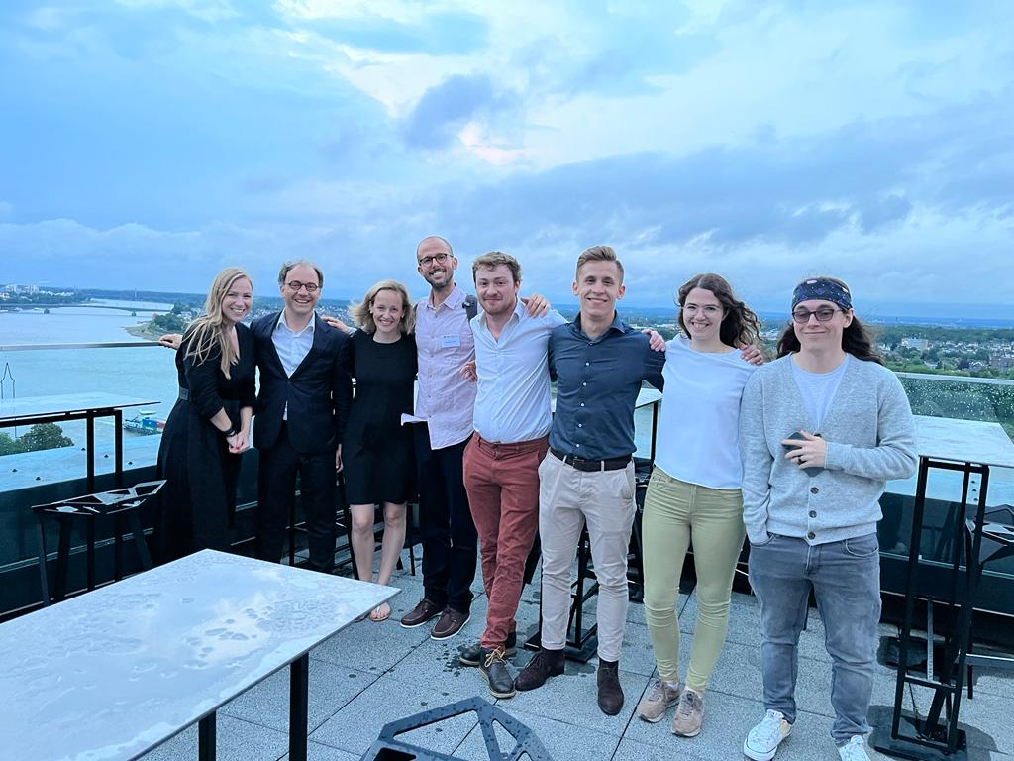

The Royal Society of Edinburgh-funded Stirling-based **Scottish Law and Innovation Network** (SCOTLIN) has as one its primary goals the support of a flourishing research environment for early career academics in Scotland. To pursue this goal the [**First SCOTLIN Early Career Symposium**](https://www.scotlin.org/post/1st-scotlin-early-career-scholars-symposium) was hosted by the University of Edinburgh last June. The organising committee was mostly composed of early career academics from most Scottish HEIs, with the support of senior colleagues, and coordinated by Dr Daria Onitiu, postdoc at the University of Edinburgh (and previously PhD student supervised by our Guido Noto La Diega). The theme of the symposium was “**Socio-legal processes for a sustainable future**: conceptual challenges and opportunities of law, governance, and technology for sustainable development”.

On the 31st of August, SCOTLIN and the University of Glasgow’s CREATe co-organised a **day-long workshop** on ‘[**Information Law in Scotland**’](https://www.scotlin.org/post/information-law-in-scotland-hybrid-workshop), hosted and led by Dr Marta Iljadica (Glasgow Law School). The workshop features a keynote by Scottish Law Commissioner Professor Gillian Black (University of Edinburgh) and fruitful conversations between academics and practitioners. Our new member of staff, Dr Jonathan Brown, was invited to deliver the **concluding address** at this event, commenting on each of the papers delivered and discussing his own views on legal taxonomy and the identification of ‘Information Law’ as a ‘contextual category’ of Scottish jurisprudence.

# **Upcoming events**

In partnership with SCOTLIN and reCreating Europe, the UK Copyright and Creative Economy Centre (CREATe) invites you to the two-day conference “***Copyright Evidence*: *Synthesis and Futures***” (University of Glasgow, Advanced Research Centre, 17-18 October 2022). Funded by AHRC and Horizon 2020, the aim of this hybrid event is to establish the “state of the art” of our empirical knowledge relating to copyright law and it will have a “myth busting” format. Guido Noto La Diega will be chairing one of the sessions and joins the Organising Committee in inviting everyone to register to attend remotely or to reach out if in-person attendance is preferred.

SCOTLIN also invites you to register to the next (en)lightening talk: ‘***Decolonising Copyright****’* by Jade Kouletakis (Abertay University and SCOTLIN Steering Committee), with Professor Dalindyebo Shabalala (University of Dayton, Director of the Law & Tech Program). The event will take place on Zoom on Thursday 27th October 2022 at 3pm BST. You are welcome to register [here](https://www.eventbrite.co.uk/e/enlightening-talk-with-jade-kouletakis-abertay-university-tickets-425279361017).

# **Upwards and onwards**

While we are delighted to welcome Hannah Prothero and Eileen Rosenberg to the Law & Philosophy Office, we are sad to Melissa Morton, who prior to being the Operational Manager of the Faculty was a fantastic Faculty Administrator in charge of our Division. Thank you so much for keeping us afloat, for your patience and professionalism, we wish you all the very best in your future endeavours!

# **Get in touch**

If you would like to contribute or suggest anything for future bulletins, please get in touch with [Guido](mailto:gn12@stir.ac.uk).