Honorary Degree Nomination Form

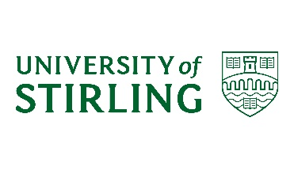

ALL NOMINATIONS MUST REMAIN CONFIDENTIAL AND MUST NOT BE DISCUSSED WITH THE NOMINEE AT ANY TIME

Nominee Details

Full Name:
Email:
Telephone:
Address:

Nomination Details

The University can grant two types of Honorary Degree – Doctor of the University (DUniv) and Master of Arts (MA). Further details on these awards can be accessed from Honorary Degree Nominations | About | University of Stirling

Type of degree:

Brief reason/basis for award:

Detailed Case for Award

Nominator Statement in Support of Nomination

Nominator Name: | Faculty/Directorate:  Date:
Nominator Signature: | Date:

In the event that the nominee is approved and accepts the Honorary Degree, the nominator will be expected to support the preparation of the laureation for the graduation ceremony.

Please sign and return the completed form to:
Academic Quality and Governance, Academic Registry at quality@stir.ac.uk

