Sustainability Plan 2022-28

Mission
Since its foundation, the University of Stirling has been a place where the status quo is actively challenged. We have a constant desire to innovate and improve to benefit society and make a difference to the communities we serve – locally, nationally, and globally. Our mission is not only to create knowledge and deliver education with a purpose, but to lead by example, playing our part in creating a better future for generations to come.

We know that the challenges facing the world we live in are formidable, and that the climate emergency strikes at the heart of – and is compounding – issues of injustice, insecurity and inequality. Our response in the face of this needs to be strong and bold, as we embrace new ways of living and working. Recognising the Scottish Government’s ambition to build a fairer, greener society, our duties as a public body, and our commitment to supporting the United Nations Sustainability Development Goals, the University of Stirling is wholeheartedly committed to addressing the sustainability of our planet.

In doing so, we commit to reducing our carbon emissions to net zero by 2040. We also commit to embedding the principles of sustainability throughout our services and operations, promoting research and teaching on climate change and sustainability, and supporting responsible environmental behaviour. We commit to enhancing the biodiversity of our campus and to putting in place adaptation measures to deal with climate change and extreme weather events. Alongside this, we also commit to supporting good physical and mental health across our staff and student communities, and to working with our strategic partners to deliver a sustainable future, both at home and further afield.

As an anchor institution within the Forth Valley Region, we understand the pivotal role the University of Stirling plays in helping to improve and enrich the lives of local communities, our leadership in the widening participation agenda, and the support and advice we offer partner organisations and businesses. Nowhere is this partnership approach more apparent – or more important – than in our efforts to address climate change and the socially responsible sustainability challenges we all face.

The University is a key signatory to the ‘Forth Valley for Net Zero’ campaign which commits Stirling to sharing best practice with our strategic partners and to help the region achieve net zero status by 2040. We have also recently signed an innovative Sustainable Growth Agreement with the Scottish Environment Protection Agency (SEPA). This is the first of many such agreements to be facilitated by Scotland’s International Environment Centre (SIEC), launched in November 2021 by the University as part of the Stirling and Clackmannanshire City Region Deal. The Centre brings together experts, partner organisations and stakeholders to advance practical solutions to climate change, support a just transition to net zero, and help deliver more inclusive growth and prosperity throughout Scotland and beyond.

Recognising the need and the urgency to act, and the vital role universities play in leading the development of sustainable solutions, the University of Stirling has committed to the principles set out in the United Nations Framework Convention on Climate Change (1992). Supporting the United Nations Sustainable Development Goals, we are a signatory to both the Sustainable Development Goals (SDG) Accord and the Race to Zero for Universities and Colleges campaign. In doing so, we have publicly committed not only to protecting our environment and to the reduction of our own carbon emissions but also to the development of a range of socially sustainable solutions. This includes climate justice and actions to reduce poverty, improved access to education, and progressive work practices that better support the well-being of our staff and students.

Our Sustainability Plan details the actions we will take to meet these ambitious targets. We have also included an overview of the progress made to date and an honest account of the challenges we face in meeting our sustainability goals (see Annex).

Although we accept we do not have all the answers yet, we remain confident that we will find ways of meeting our obligations with regards to the environment and the wider sustainability agenda while, at the same time, continuing to flourish as an internationally focused teaching and research-intensive university.

We recognise that, to some extent, the pace by which we achieve these ambitious targets will be shaped by developments in industry and society and the level of support provided by government. The emergence of new green technologies, renewable energy infrastructure, and the availability of external funding will all prove important. But it is our people and the communities we represent that will ultimately help us meet our targets and achieve our goals. This will rely on our leadership and commitment from everyone across the University to make this happen.

Acknowledging the many challenges that lie ahead, we believe that the sustainability objectives identified in this plan are ambitious but achievable if we can harness the combined efforts of our staff, students, and regional partners. We will all be impacted by climate change. Our response must embrace everyone and everything that we do.
Professor Sir Gerry McCormac Principal and Vice Chancellor January 2022

Sustainability Plan (2022-28)
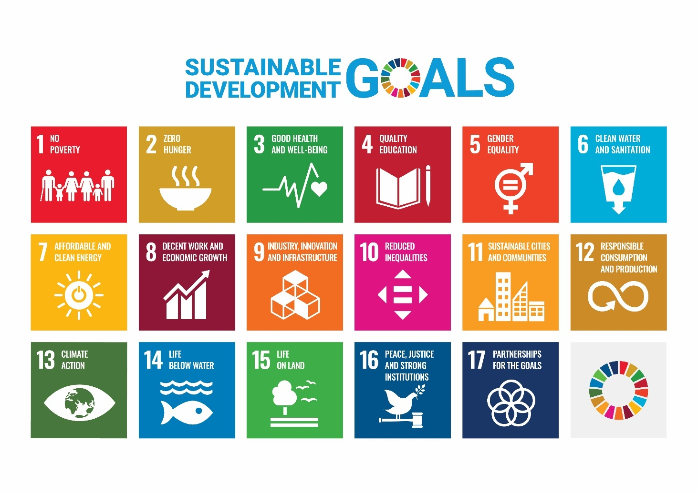
Our Sustainability Plan details the actions we seek to take as an institution to deliver a net zero carbon university by 2040, and to address the many environmental and sustainability challenges we face as a university. The plan provides an overview of our ambitious sustainability agenda, its key objectives and (where appropriate) interim milestones. We have also identified those areas within the University who are the ‘response leads’ for ensuring progress against these various objectives, but we recognise that the success of this plan ultimately depends upon everyone’s engagement. It is a joint endeavour between the University, its staff and students, communities beyond the University, and regional partners.

Our primary goal is to reduce Scope 1 and 2 carbon emissions as quickly as possible but we also recognise that sustainability speaks to our wider civic responsibilities, how we behave as an institution, how we support the communities around us, and how we care for and support our staff and students. This is reflected in our commitment to the United Nations Sustainability Development Goals (SDGs) framework (shown above) which provides a conceptual structure to better understand what we need to do as a socially responsible institution and as individual citizens to help create a better world for future generations.

Developed as part of the UN’s 2030 Agenda for Sustainable Development, the 17 SDGs constitute a high-level framework to promote a better future (see here for more detail). The SDGs are also embedded within the Scottish Government’s National Outcomes framework which, as a leading institution in the Scottish Higher Education sector we are required to deliver on.

We have identified six overarching and intersecting themes that represent our key objectives for delivering on sustainability. Each of the themes have been mapped on to the SDGs and detail the actions that will be undertaken to achieve these objectives.

It is important to note here that this plan should be regarded as a live document and will be subject to change as our thinking about sustainability develops and matures. Medium to longer term iterations of the plan will, for example, consider how supply chain Scope 3 emissions can be better managed or reduced. A more detailed account of our thinking and progress thus far is provided in the Annex to this plan.

Our progress against the objectives set out in this plan will be subject to annual review by the University’s Corporate Sustainability Steering Group (CSSG). Progress will be made publicly available and formally monitored by University Court.

Note: This plan supersedes all previous sustainability plans and should be read in conjunction with supporting institutional policies and frameworks noted in this document, including our Business Travel and Expenses Policy, Socially Responsible Investment Policy, Mental Health and Wellbeing Strategy, Equality Outcomes, Campus Master Plan and our Agile Working Framework.

Theme 1: Carbon (Energy) Management

Our principal aim in Carbon (Energy) Management is to drive down gas emissions via reductions in energy use and water consumption, and to support the delivery of a greener, more sustainable campus environment.

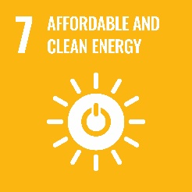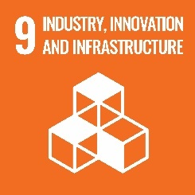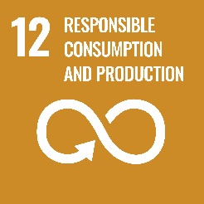

Key Objective (1): To achieve net zero CO2 emissions by 2040 at the latest

Interim Targets: To reduce CO2 emissions by 60% by 2025; 75% by 2030; and 85% by 2035

Response Lead: Estates & Campus Services

We will achieve this by:

- Systematically replacing our ageing and inefficient campus infrastructure
- Upgrading the energy efficiency of our buildings through better insulation, cladding and glazing
- Developing green and cost-effective alternatives to our Combined Heating and Power (CHP) plant (e.g. solar, wind and/or geothermal)
- Installing air and soil heat pumps, and biomass heating systems across the campus
- Prioritising sustainability projects in capital expenditure
- Exploring options for upgrading and repurposing our buildings before new developments are considered (in line with our Campus Master Plan), and ensuring new and refurbished buildings are constructed to the highest environmental standards wherever possible
- Reducing water consumption by 50% by 2030
- Exploring smart grid technology and cross-boundary energy options
- Promoting responsible energy consumption and behaviours via our Green Champions
- Working with regional partners to find solutions to poor regional transport infrastructure
- Promoting green travel options
- Adopting a ‘whole systems’ approach to support the transition to net zero by 2040

Theme 2: Sustainable Waste and Recycling

Our principal aim in Sustainable Waste and Recycling is to minimise the environmental impact of waste by promoting a circular economy and better separation of waste, reuse, recycling, and reprocessing.

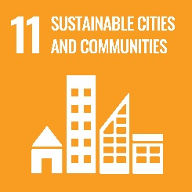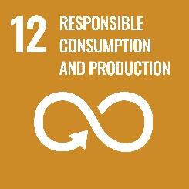

Key Objective (2): To reduce waste mass by 50% by 2030

Interim Target: To reduce waste mass by 40% by 2025

Response Leads: Estates & Campus Services; Commercial Services

We will achieve this by:
- Introducing better waste separation facilities
- Maintaining a 100% landfill avoidance strategy for all commercial waste
- Eliminating all single-use plastic in campus catering outlets and laboratories by 2025
- Converting cooking oil to biofuel
- Using coffee grounds as composting material
- Increasing awareness of recycling through communication campaigns and clear signage
- Making best use of technology and digital ways of working to reduce printing and office supplies

Theme 3: Finance and Sustainable Procurement

Our principal aim in Finance and Procurement is to make financial decisions that are consistent with our sustainability goals, to prioritise carbon-zero projects in capital planning wherever possible, and to embed the principles of progressive procurement throughout our activities.

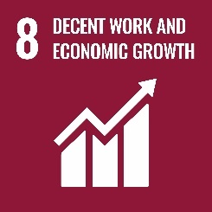

Key Objective (3): To prioritise sustainability in financial decision-making

Response Lead: Finance

We will achieve this by:

- Working with regional partners to promote a just transition towards a net zero carbon economy
- Putting sustainability ‘front and centre’ in the award of contracts, thereby promoting a wider ‘ecosystem’ of sustainable suppliers and products
- Increasing engagement with local suppliers who support the University’s net zero ambitions
- Maintaining our policy of ‘no investment in fossil fuels’, aligned to our Socially Responsible Investment Policy
- Increasing the community benefits delivered by our contracts
- Identifying high sustainability impact suppliers
- Committing to an accredited carbon offsetting scheme for all university business travel by 2023

Theme 4: People, Green Travel & Partnerships

Our principal aim in People, Green Travel and Partnerships is to implement progressive work practices to support a better work-life balance; to embed the principles of equality, diversity, and inclusion throughout everything we do; and to facilitate the uptake of green travel options.

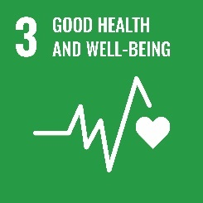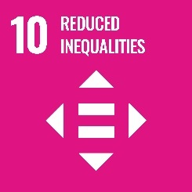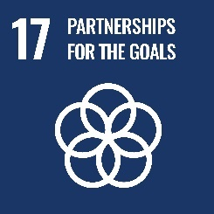

Key Objective (4): To implement progressive work practices to support a better work-life balance, and to support and improve green travel options

Response Leads: Human Resources & Organisation Development; Estates & Campus Services

We will achieve this by:

- Embedding sustainability principles within our approach to working by 2025
- Continuing to lead on the widening access agenda
- Developing progressive work practices to support good physical and mental health, underpinned by our Mental Health Strategy
- Continuing to promote equality, diversity, and inclusion across everything we do in line with our published Equality Outcomes
- Playing a key role in delivering local, regional, and national sustainability objectives through active participation in external partnerships and campaigns
- Promoting green travel options and behaviour change through a Green Champions network
- Reducing carbon emissions associated with business travel
- Working with regional partners to find green travel solutions to help address regional infrastructure challenges
- Improving the information available to staff and students regarding the carbon footprint of food and meals on campus and expanding vegan and vegetarian options
- Delivering sustainability awareness campaigns

Theme 5: Sustainability in Teaching, Learning and Research

Our principal aim in Teaching, Learning and Research is to develop the competencies, skills and attributes that will equip our graduates to meet future sustainability challenges, to embed sustainability within our research, and to help communities across the world to find sustainable solutions.

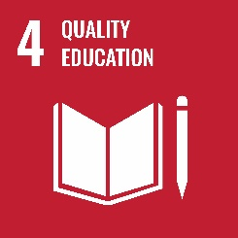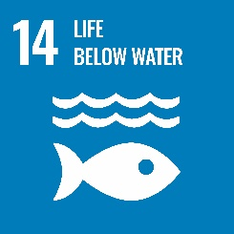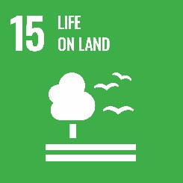

Key Objective (5): To embed sustainability across our teaching and research

Response Lead: Research, Innovation & Business Engagement; Faculties

We will achieve this by:
- Embedding education about and for sustainability and climate change
- Embedding the UN Sustainable Development Goals across our teaching and research
- Promoting and sharing best practice to inspire, educate and improve teaching and research for sustainability
- Ensuring the student voice contributes to developments in sustainable teaching and learning
- Adopting LEAF – the Laboratory Efficiency Assessment Framework – to reduce waste and increase sustainability in our science labs
- Improving sustainability literacy among our staff and students
- Using our research and teaching to encourage personal and collective behaviour change
- Reducing the impact of undertaking our research on the environment
- Embedding sustainability and the SDGs in our new Mission Oriented Research framework

Theme 6: Climate Adaptation and Biodiversity

Our principal aim in Climate Adaptation and Biodiversity is to take all necessary steps to mitigate or avoid the impacts of climate change and extreme weather on the University estate and surrounding areas, to safeguard business continuity, and to enhance the University’s unique estate to further biodiversity.

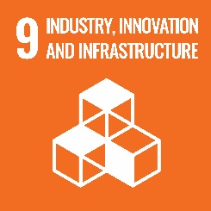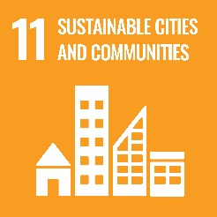

Key Objective (6): To take actions to avoid the impact of climate change and extreme weather events on campus

Response Lead: Estates & Campus Services

We will achieve this by:

- Putting in place mitigating actions to ensure business continuity and the well-being of staff and students
- Improving drainage across the campus to mitigate the effects of extreme weather events
- Developing a climate adaptation framework to address the potential impact of extreme weather conditions
- Producing an environmental climate change risk register
- Incorporating Climate Change Adaptation into the design of news builds and refurbishment programmes
- Creating habitats to promote species rich areas on campus
- Improving the age and canopy structure of our woodland
- Developing the biodiversity of our estate through the protection and restoration of habitat, and the control of non-native invasive species
- Engaging with our staff and student communities, and external partners, in the development of a new biodiversity action plan

Annex
This Annex provides a more detailed overview of our thinking and the progress we have made so far with regards to the sustainability objectives outlined in our Sustainability Plan.

Theme 1: Carbon (Energy) Management
Progress: By investing in our campus energy infrastructure and upgrading the energy efficiency of our buildings, we have been able to achieve a continuous reduction in carbon emissions since 2007/08 (i.e., the earliest year for which we have reliable and complete data). Figure 2 highlights the various sources of our emissions and the scale of change from 2007/08 to 2019/20. This covers both Scope 1 emissions (gas, oil, fleet transport fuel, biomass) and Scope 2 emissions (electricity grid). Scope 1 refers to those emissions we have direct responsibility for managing while Scope 2 refers to those emissions we can influence through our external partners that supply our energy and water (Scope 2).

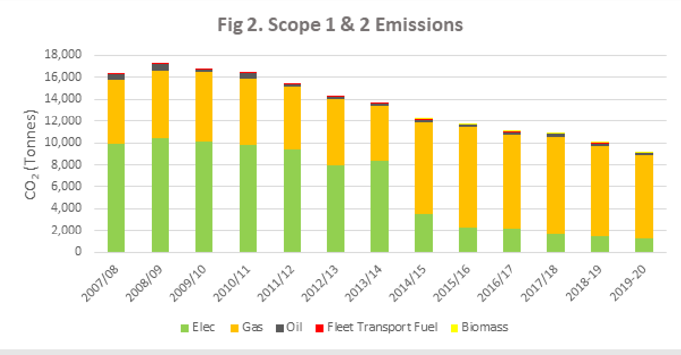

Between 2013/14 and 2014/15 we achieved an 11% reduction in Scope 1 and 2 emissions due in part to commissioning a £2.7 million 1.6 MW combined heat and power (CHP) plant. This serves the campus with locally generated electricity and makes use of waste heat to provide space heating and hot water. Although this development has proved to be energy efficient, we are mindful that more sustainable and renewable energy sources (such as solar, wind, and geothermal) will be needed. The CHP plant is due for replacement by 2030 and we are currently evaluating greener options.

Between 2007/08 and 2019/20 we have reduced our water consumption by approximately 30%, but there have been years of higher consumption, peaking in 2013/14. Following a series of leak repairs and a major £1.4 million investment in the replacement of the campus water network in 2018, water consumption has reduced markedly from 2013/14 levels. Although water in Scotland is generally not in short supply, we recognise that energy is required to heat and treat the water as it flows through the water network. Thus, it is essential that we continue to monitor water consumption and make progress toward reducing consumption year on year.
Given that over 60% of our energy emissions are associated with the generation of space heating and hot water, a major programme is underway to improve the thermal performance of our buildings and our heat delivery networks. This will seek to reduce heat loss through improved insulation, cladding and glazing. This is essential work as there is little value in producing more sustainable forms of energy if that energy is subsequently lost through poorly insulated buildings.
As we consider our own campus emissions more broadly and expand our use of electric fleet vehicles, we are aware of recent Scottish Government guidance for public bodies to plan for net zero – including working to ensure that public buildings achieve zero direct (estate-related) emissions by 2038 and transitioning to zero emissions for all new fleet vehicles (see here).
We are also exploring options for more efficient and greener energy supplies, including the development of a Forth Valley Regional Energy Plan, cross-boundary energy options and more integrated heat and water networks. We also intend to add to our existing air and soil heat pumps and biomass systems to further reduce our carbon footprint.

Our progress on energy and water consumption is already publicly available and is reported on an annual basis through the Scottish Government’s Public Bodies Climate Change Duty Reporting and via returns provided to the Higher Education Statistics Agency. Progress is also monitored annually via the University’s Corporate Sustainability Steering Group and University Court.

Theme 2: Sustainable Waste and Recycling
Progress: The key message here is that we need to avoid (or minimise wherever possible) the purchase of unnecessary products or services. Waste reduction is critically important to conserve finite resources. It also reduces associated greenhouse gas emissions, pollutants, and financial costs. By adopting a circular economy, we can address our ‘use it once and throw away’ lifestyles. This thinking underpins the steps we have taken thus far to reduce waste, conserve the earth’s scarce resources, and ultimately to provide employment in the region by sourcing more local products and services.

We also recognise, however, that we need to take further action to reduce waste levels. General waste represents approximately 65% of the University’s total waste (see Figure 3) and we are encouraging staff and students to think carefully about the disposal of used food and other waste. Improved information and signage, for instance, will help to reduce the amount of spoiled recyclable material that ends up as waste due to contamination by food or liquid. Currently, all our commercial food waste is sent to an anaerobic digester as part of our 100% landfill avoidance strategy. Cooking oil is collected and turned into biofuel, and coffee grounds are used as composting material on campus. We are also exploring with regional partners the use of food waste to generate power.

Improved waste separation facilities and campaigns to increase recycling rates will continue to feature in our strategy. Across our catering outlets, we are introducing more environmentally friendly coffee cups and take-away options, removing disposable cutlery and plastic straws, and eliminating plastic bags. We are working with our catering suppliers to remove all single-use plastics where possible. We have also taken steps to eliminate all single-use plastics in laboratories by 2025.

As a consequence of our waste reduction strategy, we have reduced overall waste mass (i.e., the amount of material thrown away) by 32.3% since 2016-17. Over the same period, the proportion of waste recycled has increased from 26.1% to 29.5%, while incinerated waste (general non- recyclable waste) has reduced from 71.7% to 65.5%.

Through its development of the ‘Green and Blue Space’, our Students’ Union recycles household items from student residences and foodstuffs. This has resulted in the recycling of approximately 6 tonnes of waste materials annually. Surplus or unwanted food stuffs are donated to local food banks for distribution in the local community.

Fig 3. University Waste Streams
As part of our pledge to provide low carbon and ethically produced food, we have reduced food mileage by switching to local food producers and suppliers wherever possible. We have increased seasonal fruit and vegetable provision throughout our catering outlets (e.g., our involvement in the Peas Please Pledge). We provide a vegan option in every outlet as a means of reducing meat and dairy consumption, and are looking to expand and promote our vegan offer. We are also exploring the introduction of a system that will better inform staff and students about the carbon footprint of the meals they purchase.

The various waste streams collected from the University are weighed and recorded independently by our waste collector. Progress towards reducing waste mass and improved recycling rates is reported on an annual basis through the Scottish Government’s Public Bodies Climate Change Duty Reporting and via returns provided to the Higher Education Statistics Agency. Progress is also monitored annually via the University’s Corporate Sustainability Steering Group and University Court.

Theme 3: Finance and Sustainable Procurement
Progress: The way in which we manage our finances has a pivotal role to play in any plan to reduce carbon emissions – not only in terms of how we prioritise and allocate resource to carbon reduction projects but the way in which we procure the goods and services we require to flourish as a leading research and teaching institution. Recognising the scale of the challenge, we are working with strategic partners across the Forth Valley to identify potential areas of collaboration to reduce the Region’s overall carbon emissions, and thereby benefit us and local communities. We are also working with regional partners to promote a just transition toward a net zero carbon economy, noting for example the recommendations of the Scottish Government’s Just Transition Commission.

We have publicly committed to reporting all capital expenditure related to sustainability projects from March 2022. We plan to make this information available our Environment and Sustainability webpage and will be reported to Court on an annual basis. When planning capital expenditure, we actively consider whether existing buildings can be repurposed rather than building anew. Where decisions are taken to build new, we ensure that they are built to Passivhaus standards or their equivalent wherever possible. Similarly, we employ Enerphit or equivalent standards for all refurbishment projects wherever possible.

Much of the University estate was built in the 1960/70s with many buildings of single brick construction and single glazed windows. A continuous programme of refurbishment and replacement of the building stock has progressively raised the thermal efficiency of our buildings. Notable improvements include a £3.9m cladding and reglazing project of the Cottrell building. A further £38m was invested in the redevelopment of campus residences. This included three new halls of residence and town houses – all of which achieved BREEAM excellent ratings for environmental performance. More recently, the £21m redevelopment of our sports facilities has incorporated a heat pump to heat/cool the building while the £22m Campus Central development employs the building’s structure as a heat sink to store and gradually release heat over night.

In order for the University to remain viable as an internationally recognised centre for teaching and research, we recognise that carbon emissions will continue to be incurred as a result of essential business travel and commuting. Thus, to reach our net-zero carbon emission targets by 2040, we will adopt a means of carbon offsetting for those stubborn carbon emissions via a recognised carbon offsetting scheme. Carbon offsetting is already a requirement to hold some research grants and it is likely to become a general pre-requisite. We therefore commit to carbon offsetting in respect of business-related travel from 2023 using an accredited carbon offsetting scheme. For the most recent pre-Covid year (2018-19) – which reflects a typical level of business travel – the University of Stirling was responsible for an estimated 1773 tonnes of CO2 (by comparison, we accounted for 101.5 tonnes of CO2 in 2019-20 during the pandemic).

We are currently working with EAUC Scotland and other partners to identify a reliable means of estimating commuting travel and to establish sector standards in this area. It is important to note here, however, that our priority remains to avoid creating carbon emissions in the first place rather than offsetting them.

In line with our long-standing socially responsible investment policy, we reaffirmed in March 2019 our commitment not to invest in fossil fuel companies (click here to see our financial policies). We will not invest in fossil fuel companies.

We also recognise that, as a major employer in the region, we have considerable economic and influencing power, especially with regards to procurement. We are in the process of finalising a new procurement strategy which recognises and encourages potential ‘new market’ entrants and new technologies. We are committed to identifying high sustainability impact suppliers and categories and will seek to employ the latest APUC tools and guidance to further improve supply chain monitoring and performance (see here).

We recognise that supplier engagement is key to delivering sustainable benefits. Our strategy, therefore, is to put sustainability ‘front and centre’ of the contract award and throughout the contract management phase (where appropriate). We will also use APUC’s (soon to be published) Scope 3 report to establish supplier and category baselines, and explore whether a targeted supplier engagement programme may prove the best means of promoting continual sustainability improvement by key suppliers.

Theme 4: People, Green Travel & Partnerships
Progress: We recognise that our staff and students are key to the success of our Sustainability Plan – not only in terms of the personal choices we make about how we work and study but also how sustainable choices can be facilitated and supported beyond work and study by our processes and policies.

Education and enhanced awareness are key drivers of behaviour change. We, therefore, proactively champion sustainability as a priority for all our communities. This is an ongoing process achieved through the leadership provided by the Principal and Vice Chancellor, Professor Sir Gerry McCormac (see here for video message) and the senior management team of the University, to the creation of awareness campaigns and the activities of our Green Champions network, through to our partnership working with staff and Trade Union representatives and engagement with our students and Students’ Union. Both Trade Union and Student Union representatives are members of the Corporate Sustainability Steering Group which has oversight of our progress against our sustainability targets. We also regularly review our core processes for the management of staff and external partnerships to ensure that responsible environmental behaviours are supported and prioritised.

As part of our commitment to sustainable development, we recognise our responsibility to support socially progressive outcomes through our employment arrangements and procurement decisions. We support the principles of the real living wage and work closely with regional Local Authority partners and NGOs in Stirlingshire, Clackmannanshire, and Falkirk to support a just transition to a green economy.

As a major employer in the region, we believe it is important to lead by example. We prioritise mental health and well-being in our staff and students. We have delivered Mental Health Awareness sessions for line managers and staff; a well-being programme for staff that focuses on developing mental well-being and resilience; provided additional rest days to support health and well-being; and an Employee Assistance Programme that gives free, confidential advice 24 hours a day, 365 days for all employees and immediate family members.

People are at the heart of all these activities. We have recently developed progressive work practices that enable staff and students to work and learn in agile ways. Most recently, we have implemented an Agile Working Framework which provides a means of achieving a better work- life balance while at the same time ensuring that institutional goals and targets are met. This new way of working has, for some staff, lessened the need to make commuting journeys on a daily basis, thereby contributing to a reduction in Scope 3 emissions. Agile working will be subject to review as we respond to changing business and staff needs.

We have been sector-leading for many years in the promotion of women’s careers. We were instrumental in the development of the influential Aurora programme which has subsequently been rolled out across the UK to support women’s career development. We also hold an institutional bronze Athena Swan award which attests to the importance we attach to equality, diversity, and inclusion. We are committed to supporting care students and students from lower socio-economic backgrounds and provide funded studentships and a research fellowship for refugees through the CARA scheme.

The University’s sustainability strategy seeks to encourage active travel and a modal shift to greener forms of transport through support and promotion which is consistent with Scottish Government’s target to reduce car mileage by 20% by 2030. We recognize that active travel needs to be at the heart of our sustainability strategy. Our progress on green travel has been made possible through continuous investment, funding, and partnerships with various travel bodies. We are committed to reducing the carbon emissions associated with business travel, and to finding greener and more sustainable options for travelling to and from university. We continue to work with Stirling Council on Park and Ride options and potential alternatives to increase green and active travel. We also are taking on board the latest guidance from EAUC and other sector partners on sustainable travel choices and promoting active travel.

We are working with Transport Scotland and regional transport companies to encourage greater use of public transport through initiatives such as discounted travel and the Scottish Government’s free bus travel scheme (from 31 January 2022) for those aged 5-21 years old. We have also played an instrumental role in the development of the Forth Valley Connectivity Commission which is tasked with finding green transport solutions across the Forth Valley Region.

We continue to increase the provision of electric vehicle chargers on campus and will seek to introduce chargers at all the University’s external residences and facilities by 2030. We have also extended the salary sacrifice bike purchase scheme to include electric bikes. Indeed, since the University first subscribed to the cycles scheme in 2016, over 180 bikes have been purchased by staff with an average of 30 cycles per year. We also continue to support bike schemes such as Next Bike to enable users a means of accessing free or low-cost bike hire. The Next Bike scheme has proved to be a great success since its inception in 2014, peaking at over 1,000 campus rentals per month.

We have made significant moves towards the electrification of the University’s transport fleet, and this should be completed by 2025. We have also adopted the use of e-cargo bikes across campus for Estates and Commercial Services Staff which has offset the need for diesel vans. These measures not only support our carbon reduction targets but enhance the health and well-being of our staff and students.
Partnership working is key to achieving our carbon emissions targets. In particular, we value the working relationship with our Students’ Union who have actively contributed throughout the development of this Plan and the setting of sustainability targets. The Students’ Union delivers a range of activities and plans which are complementary to the University’s Sustainability Plan – more about their work can be found here.
We are committed to working with our regional partners to find sustainable green solutions. Working closely with Stirling, Clackmannanshire, and Falkirk Councils, we are exploring greener forms of travel that will benefit all our communities. We are also exploring alternative forms of energy such as geothermal as an alternative to fossil fuels with a view to the development of local heating systems that will benefit not only the University but surrounding communities. Finally, we are working closely with NHS Forth Valley and our colleagues in Forth Valley College to explore how we can work together to drive down carbon emissions.

Progress on people, green travel, and partnerships is monitored through our Corporate Sustainability Steering Group, and reported via The Scottish Government’s Public Bodies Climate Change Duty (PBCCDR), and via HESA’s Estate Management return. Progress on fair and inclusive work is reported through a variety of different routes, including the Scottish Government’s Public Sector Equality Duty (PSED) and HESA’s Staff Record reporting. Staff-related matters are regularly discussed and reviewed through a series of informal meetings with trade union representatives and through the Combined Joint Negotiating and Consultation Committee (CJNCC).

Theme 5: Sustainability in Teaching, Learning and Research
Progress: Education for Sustainability Development (EDS) is fundamental in bringing about the kind of behaviour change required to address the breadth of interconnected environmental and social issues we face. It is essential that future generations are equipped with the necessary information to understand the challenges ahead, to empower individuals to reflect on their own actions, and to provide local and global perspectives that will enable us to live and work in a sustainable manner.

The University of Stirling’s is committed to embedding Education for Sustainable Development across all its Faculties and we encourage students to think about their role in supporting sustainability through our Graduate Attributes. Faculties such as the Stirling Management School have led the way by embedding SDGs throughout its undergraduate and postgraduate programmes, including organisational leadership on sustainability, sustainable business administration, and strategic sustainable business. SMS is an advanced signatory to PRME (Principles for Responsible Management) which is based on the UN’s SDGs and provides the basis for sharing best practice to support similar initiatives across other Faculties. The Faculty of Arts and Humanities have created a sector- leading programme on human rights and diplomacy which is taught in partnership with the United Nations Institute of Training and Research (UNITAR), and sustainability principles are being embedded across programmes within the Faculties of Social Sciences, and Natural Sciences. Biological and Environmental Sciences have also enhanced the provision of local and Scottish-based field teaching to reduce the associated carbon footprint.

Each Faculty is developing its own sustainability agenda in the curriculum and are working to adopt sustainable work practices across all teaching and research laboratories. We are also piloting the adoption of LEAF (Laboratory Efficiency Assessment Framework) as a mechanism to improve sustainable working practices in both teaching and research laboratories.

Despite these advances, we recognise that there is still much to achieve. We are keen to enhance the sustainability literacy of our staff and are currently looking at ways in which this can be implemented. We are also scoping out a sustainability literacy module that could be taken by all students. This will further support student employability and ensure that sustainability principles are implemented beyond the University. Similarly, we are exploring how we can support local communities, school children, and businesses via short on-line courses in sustainability literacy to help them achieve their own carbon reduction targets.

To deliver on these ambitious targets, we have established a pan-University Sustainability Learning & Teaching working group which reports directly to our Education and Student Experience Committee and Corporate Sustainability Steering Group. Through engagement with this working group, staff, Faculty Officers, module reps, and students have a voice in these important developments. Our new Mission Oriented Research Programme will similarly bring together and provide a focus for our research strengths in sustainability and the environment.

Our Students’ Union has heightened awareness of the role of sustainability in the curriculum by hosting the Stirling Climate Festival which, along with sustainability partners, is set to become an annual event. Our Careers and Employability Service supports graduates in influencing sustainable development in the workplace which, in turn, helps to drive forward sustainable change in the wider community.
We will actively promote the issue of how we conduct our research in a more sustainable manner, including making use of sustainable travel apps to support staff and students making travel and fieldwork bookings. We are also in the process of redesigning our postgraduate and research induction sessions to ensure that our research is conducted in as sustainable a manner as possible.

In addition to how we conduct our research, a great deal of our research is focused on the environment, environmental change, sustainability, and the UN’s SDGs. Through the development of the City and Regional Deal projects we are working towards delivering national and international sustainability solutions via cutting-edge environmental research projects. Scotland’s International Environment Centre has been set up not only to provide sustainable solutions for the region and Scotland but also internationally by bringing together the latest scientific research, technological advances, policy makers, NGOs and industry.

The Faculty of Natural Sciences is leading on research that seeks to improve the sustainability of environmental management, decision-making and production systems through better resource management and planning, the development of nature-based solutions and more effective use of environmental informatics and sensor technology in decision-making. The Forth-ERA project (an innovative partnership with BT and Scottish Water) uses the latest satellite technology to inform our understanding of flooding and how best to respond to it. We are also working to better understand how to restore forests and woodlands through work in the UK via the WrEN project and across tropical forest systems in Asia, Central America, and Africa.

For over 50 years, the Institute of Aquaculture has played a fundamental role in ensuring food security and meeting the nutritional needs of communities across the world. We continue to work to improve the sustainability of aquaculture systems by refining our understanding of how we model and benefit from marine microclimates, and improved vaccine and nature-based solutions to pest and pathogen management, thereby improving both animal welfare and reducing the environmental impact of production.

Progress in this area will be reviewed and monitored through the committees noted above and via our University Court on an annual basis. Activity in this area will also feature in our Scottish Government’s Public Bodies Climate Change Duty Reporting.

Theme 6: Climate Adaptation and Biodiversity
Progress: We recognise that climate change and extreme weather conditions pose significant risks to business continuity. This was borne out in 2019 when the University suffered severe and unprecedented floods causing over £10 million of damage to buildings and grounds. The impacts were far-reaching with restoration taking over a year to complete. Since then, significant work has been carried out to improve drainage across the campus, and to find natural solutions to challenges posed by climate change and extreme weather events.
In addition to physical alterations to our campus, we have in place a Severe Weather Response Plan which sets out how the University co-ordinates its response to severe weather events. Also, the Major Incident Response Team (MIRT) has procedures in place to deal with emergencies, including severe weather impacts.

In keeping with our legal duty to adapt our buildings and estate to climate change (Climate Change (Scotland) Act 2009) and to build further resilience into our business practices, the University has put in place a climate change adaptation programme to ensure that it is better placed to avoid or mitigate the effects of severe weather (e.g., by replacing hard paths with gravel or other porous material where appropriate). We are also exploring the use of Sustainable Drainage Systems (SuDS), especially in new build designs to better manage increased surface water.
Risk assessments have been carried out across all faculties and directorates to identify any vulnerabilities to extreme weather events, and these will form the basis of an active climate change risk register, monitored by the Corporate Sustainability Steering Group. In doing so, we have identified building areas that are prone to extreme temperatures and have taken appropriate mitigating actions. We have installed non-return valves in waste networks to avoid the back up of waste into buildings in the event of floods and have improved drainage and air spaces in waterlogged areas to reduce run-off and to prevent tree root death. We have also undertaken significant ground works on the edge of Airthrey Loch to help stabilise banks that have become eroded over time.
It is recognised that urgent action is required to find solutions to rapidly changing ecosystems and the loss of biodiversity across the world. The University actively manages its 334-acre estate in terms of biodiversity and boasts a rich and diverse range of plant and animal life, including several threatened or endangered species (e.g., pine martens and red squirrels). We have increased the provision of dead wood to provide habitats for fungi and invertebrates and increased the provision of nesting boxes for bird and bat species. In doing so, we have enhanced staff, student, and community awareness of the biodiversity of the campus and promoted these habitats as educational and recreational resources. Biodiversity is also a key priority in the development of all new University building projects.
In terms of the maintenance of the campus, we continue to adapt maintenance regimes that are sympathetic to biodiversity. We have adopted the use of natural plant-based products to treat weeds (e.g., the use of Pelargonium extract) and have returned much of the 12-acre golf course to natural parkland meadow. We have created ecotones (transition areas that are species-rich) to increase nectar-bearing flowers and seed-heads through the reduction in grass cutting. We have also increased the planting of native tree and shrub species to add to and diversify food sources for invertebrates and birds, and edible fruiting species for human consumption. We are currently updating our Biodiversity Plan and will publish it on the website when available.
A large proportion of our estate is woodland and comprises approximately 5,000 mature trees. We are taking steps to systematically improve the age and canopy structure of our woodlands through the planting of long-lived tree species. We have also improved the green network routes for small mammals through habitat linkage between wetlands and hedge or woodland edges. In taking forward all these actions, we are gradually restoring much of the University campus to the original 18th century Airthrey Estate.
Progress in terms of biodiversity is monitored and reported to the Corporate Sustainability Steering Group, and via our reports to Scottish Government.

Measured against a 2007/08 baseline
Measured on 2016/17-2018/19 average baselines

